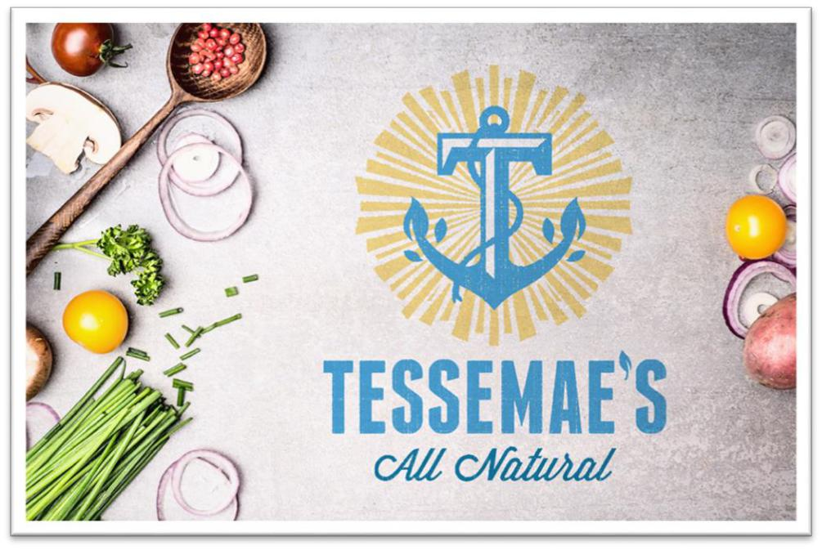

Game On: Amplifying Influencer Effect with Tessemae’s All-Natural

By Naadiya Faison and Danielle Sloan
Department of Marketing and Supply Chain Management, East Carolina University (Arthur)
MKTG7652: Integrated Marketing Communications (IMC)
Dr. Diana Haytko
November 21, 2023

Contents
Executive Summary 2
Situational Analysis 4
Industry Information 4
Figure 1 6
Figure 2 8
Figure 3 9
SWOT Analysis 9
Figure 4 10
Client Background 11
Problem 12
Target Market 12
Segmentation 13
Target Markets of Interest 16
Buyer Persona 16
Figure 5 18
Competition 18
Figure 6 19
Objectives 22
Strategy 24
Table 1 25
#IGotTheSauce Hashtag 25
Figure 7 26
Figure 8 28
Unlocking Human Motivation with the OFC 28
The Flavor Funnel 29
Figure 9 30
NIL Deals: Female College Athletes 30
Table 2 31
Purse-Stable Picantes (Limited Time Only) 33
Figure 10 34
Tactics 35
Channel Specific Tactics 35
Instagram 36
Figure 11 37
Pinterest 37
Figure 12 38
Facebook 38
Figure 13 40
Figure 14 41
Identification of Example Players 41
Content Development and Curation 42
Table 3 42
Sponsorship Approach 43
Monitoring and Analytics 44
Community Engagement and Interaction 44
Integration with Overall Marketing Strategy 45
Tactic Summary 45
Budget 46
Table 4 48
Control and Implementation 50
Figure 15 52
Table 4 53
Conclusion 54
References 56
Appendix A 70
Appendix B 71
Output: B1 71
Output: B2 72
Output: B3 72
Appendix C 74
Problem Statement 74
Methods 74
Sample 74
Experiment 75
Appendix D 77
Survey: D1 77
Respondents: D2 77
Appendix E 80
Executive Summary
Sloan and Faison (2023) developed an IMC program from psychological theory, neuroeconomics, and customer insights by targeting the market, utilizing motives, and innovating new value for the customer. Using original research, machine learning, and expert input, researchers narrowed the customer base to a target market segment of trend-dieters and a serviceable obtainable market represented by the Sophia Greenwell persona (Chi, 2023). Sloan and Faison (2023) then analyzed these stakeholder groups for motives guided by reward-seeking, pleasure centers in the brain (Smith & Huettel, 2011). Finally, the team generated a plan to innovate new value for the customer using the #IGotTheSauce hashtag, developing adjacencies with complementary items like purse-stable picantes, implementing a social media “flavor” funnel, and capitalizing on name, image, and likeness (NIL) partnerships with strong, female athletes. This foundational strategy pivots Tessemae's toward realizing ambitious communication objectives for sustainable growth.
This comprehensive strategy enhances Tessemae's online presence by targeting brand awareness, stabilizing conversion rates, and boosting follower growth rates, all supported by a studious monitoring and evaluation framework. This plan is annually forecasted to increase brand awareness by 28.57% through Instagram engagement, stabilize conversions at five percent using social media funneling, and increase the follower growth rate to a stable five percent. A detailed monitoring and evaluation plan was outlined in Control and Implementation, detailing weekly strategizing and refining. With these targeted objectives and a robust monitoring and evaluation framework, Tessemae's is well-positioned to become a digital nomad within the coming year.
Researchers employed organic and paid advertising on Instagram, Pinterest, and Facebook using athletic micro-influencers, product placement, and brand watermarks. Every social media channel will have a unique branding purpose, including Instagram for interpersonal use of trending reels, Pinterest for recipe boards and pins, and Facebook for magnified segmentation on paid advertisements. Tessemae’s will utilize NIL partnerships with athletic micro-influencers, like Caisa-Marie Lindfors, product innovation with limited-time-only pocket picantes, and conversion looping using the flavor funnel. Despite fiscal hardships and legal battles, Tessemae’s will realign itself as a five-ingredient, organic dressing star company.

Situational Analysis
Before the creation process, experimenters must understand the landscape. Therefore, investigators performed a situational analysis using industry information, client background, a problem statement, segmentation, and competition analysis. These elements will illustrate landscape prior to creative application.

Industry Information
The clean-ingredient salad dressing industry is a disruptive market within the broader food industry focusing on producing salad dressings made from natural, wholesome, and minimally processed ingredients. According to Prewett and Vetter (2022), the product that disrupted the clean-eating salad dressing market was Greg Vetter, CEO’s mother Teresa’s lemon-garlic salad dressing recipe. Key aspects of the clean salad dressing market are consumer awareness and preferences, market trends, ingredients, sustainability, distribution channels, and challenges. The clean-ingredient salad dressing market has gained significant momentum from the increasing consumer awareness and demand for healthier and more sustainable food options. In 2019, Tessemae’s further disrupted the industry with its new shelf-stable creamy ranch dressings. According to Prewett and Vetter (2022), “The shelf-stable category is fifteen times the size of the refrigerated dressing set” (17:50). The clean-ingredient salad dressing market, epitomized by Tessemae's innovations, is driven by growing consumer demand for healthier, ethically transparent, and sustainable food choices.
The disruptive market created by Tessemae’s has gained the attention of millennial clean eaters everywhere. These consumers are increasingly health conscious and actively seek products with unsullied labels, fewer additives, and ethical manufacturing. Pew Research Center states, "retail sales of organic foods more than doubled from 1994 to 2014 with a steady uptick of about 10% annual growth in retail sales per year” (p. 01). Conscious consumers scrupulously read labels, follow diet trends, and conscientiously source their meals. Tessemae’s has met these demands through its all-natural, certified organic salad dressings and sauces with ingredients consumers can pronounce, comprehend, and inculpably enjoy.
Health food market trends show longevity, minimal risk, and upward-shifting growth. Tessemae’s has ridden the healthy living trend upward as a thought leader among clean-eating foodies. The clean-ingredient salad dressing industry has burgeoned throughout the age of increased salad consumption and the impending need to go green. Companies in this industry are “small i” innovating by introducing new flavor profiles, utilizing fermentation, creating enticing packaging, and using superfoods and probiotics in dressings (Day & Moorman, 2011, pp 94-95). Despite the imitators, Tessemae’s sits proudly atop Whole Foods, Walmart, and Amazon shelves as the original five-ingredient dressing.
Tesseamae’s ethical eating values are evident in the branding, innovation choices, and business model. The key to Tessemae’s clean-ingredient dressings are the organically sourced, pronounceable, non-GMO ingredients that work to “amplify taste and simplify food” (Tessemae’s, n.d. b, p. 01). The industry focuses on organic, non-GMO ingredients and eliminating artificial colors, flavors, and preservatives without sacrificing taste. Prewett and Vetter (2022) enthusiastically proclaim that when Tessemae’s created its “great-tasting, shelf-stable, clean ranch dressing,” which is the first of its kind, the salad dressing market was further disrupted (18:05). Tessemae’s has reinvented the cult of personality and paved the way for foodie culture by pursuing the importance of organic food consumption.
There has correspondingly been a sustainability initiative within the industry dating back to 2014, far beyond going green becoming a mainstream effort. To reduce its carbon footprint, the company has continuously recyclable and biodegradable packaging. The dressings come packaged in glass bottles featuring the iconic anchor logo, pronounceable ingredients, the Certified Non-GMO Project’s Climate Pledge stamp, and a small lid secured with shrink wrap (Tessemae’s All-Natural, n.d.). Early bottles featured differentiated packaging with hand-dipped sealing wax dripping from the top (Drumheller, 2015) (see Figure 1). Tessemae’s has exceeded performance parity with its packaging and point-of-purchase displays. The bottle looks like a status symbol among the sea of plastic bottles on the surrounding shelf space.

Figure 1
Organic Elegance: The Evolution of The Tessemae’s Bottle
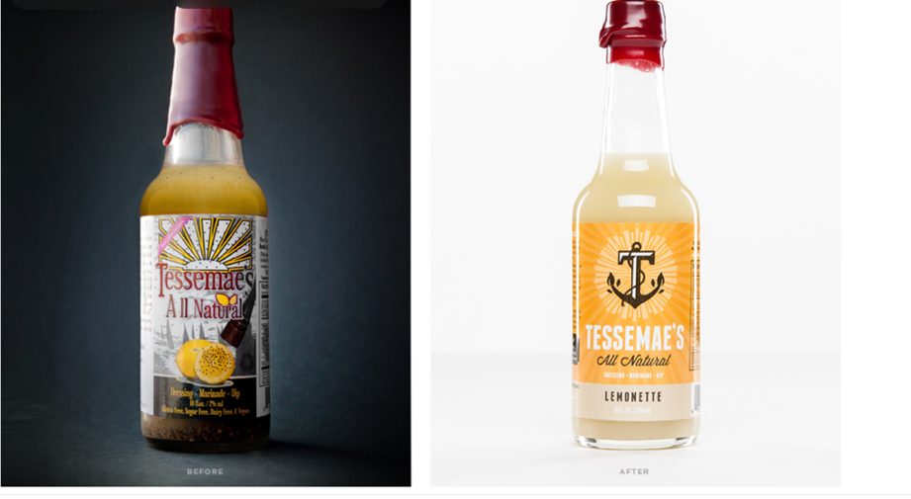
Note. The evolution of the Tessemae’s bottle speaks to the company’s journey from a family heirloom recipe to a national corporate player within the organic food industry. This package update from Jason Drumheller (2015) sent the brand into exponential growth.
Although Tessemae’s began in specialty health food stores, like Whole Foods Markets, it has since expanded its distribution channels to include mainstream supermarkets and online retailers. “Big i” innovations, like market penetration using shelf-stable ranch dressings, exotic and ethnic dips, and packaging revamps in 2014 and 2022, have imbued company growth (Day & Moorman, 2011, pp. 93-94). When Tessemae’s began offering shelf-stable ranch dressings and sauces, an augmented growth began that kept strong until the COVID-19 lockdown (Prewett & Vetter, 2022). The repeated market disruptions put forth by this company have chiseled out a subculture of loyal followers, both business and consumer, who revel in brand success. Likewise, increasing demand for digital convenience has brought Tessemae’s to online retailers, such as Amazon and Instacart. Despite penetrating the mainstream, the brand still considers specialty health food stores its original home.
However, Tessemae’s success has not come without challenges. Internal conflicts include C-suite disputes and battles over company shares and external threats include price sensitivity and regulatory difficulties. Tessemae’s has a drive to make sustainability affordable to everyone, but this has come at the detriment of performance parity. Attempts to fix the pricing discrepancy have resulted in price sensitivity from product allies. Clean-ingredient products tend to be pricier due to the prohibitive cost of natural and organic ingredients (Skin, 2022). Navigating the regulatory environment of organic, all-natural, and non-GMO foodstuffs can also be arduous. Ensuring products meet organic and non-GMO qualifications and other regulatory compliances can similarly be demanding. Amidst internal conflicts and external challenges, Tessemae's continues to maintain affordability and meet stringent regulatory standards in its pursuit of affordable, sustainable, and clean-ingredient products.
Conflict exacerbates turbulence between Greg Vetter and past advisors. This conflict is foundational to the ongoing Tessemae’s v. McDevitt lawsuit naming Michael S. McDevitt and his team at Tandem Growth Group for Racketeering and Fraud (Tessemae's, LLC v. McDevitt, 2021). Hardships proceeded this lawsuit, leading Tessemae’s to voluntarily file Chapter 11 in February 2023 (Tessemae’s, 2023). Greg Vetter, CEO, and the rest of Tessemae’s 39-member crew remain hopeful about safeguarding their competitive advantage within the organic salad dressing market (Craft, n.d.). The internal conflict culminating in the Tessemae's v. McDevitt lawsuit and subsequent Chapter 11 filing presents significant challenges for the company, yet CEO Greg Vetter and his team remain optimistic about maintaining their position in the organic salad dressing market.
Company marketing and branding styles focus on spreading a clean eating culture throughout urban millennial populations using campy marketing, social good appeal, and dieting trend affiliations. Brand knowledge and appeal to emotional storytelling are some of the strategies currently employed through blogs, social media, and in-store experiences educating and selling consumers on the benefits of conscientious eating habits. Brands often connect with customers through a story about their ingredients, sourcing, or the inspiration behind the products. Emphatically, the Tessemae’s official website features the soul-warming tale of the Vetter family whose impregnable bond is evident from the photo on the Tessemae’s Our Story page (see Figure 2). Greg and his two brothers are pictured enjoying momentous occasions over the dinner table with their mother, Teresa (adoringly nicknamed “Tessemae”). Family strength is a substantial influence within the unified family and brand message.

Figure 2
Seeds of Success: The Vetter Family Enjoys a Photo Shoot.

Note. The three Vetter brothers (top of photo) are pictured here with their wives, children, and mom Teresa Tessemae Vetter, from left to right they are Matthew Vetter (Chief Marketing Officer), Gregory Vetter (Chief Executive Officer), and Brian Vetter (Chief Growth Officer).
Furthermore, the competitive landscape entails the threat of constantly emerging niche brands and the adaptation of big brands into the evoked set. According to Future Market Insights (n.d.), organic salad dressings have a compound annual growth rate (CAGR) of 5.4% from 2020 to 2030, making the industry susceptible to new entrants. In fact, increasing numbers of niche brands like Primal Kitchen and Cleveland Kitchen are entering the evoked set with extremely similar value propositions, creating market dilution and noise. Likewise, established brands like Heinz and Wishbone are also adapting by introducing cleaner and more natural versions of their products, intensifying competition, crowding the market, and causing price sensitivity. This dynamic market scenario punctuates the continuous need for Tessemae's to innovate and differentiate its offerings to maintain a competitive advantage in a rapidly evolving market.
A rising consumer inclination for healthy, natural, and high-quality food has made the United States a leading region for growth in organic salad dressing sales (Market Data Forecast, 2023). Europe and Asia Pacific are also strong prospective markets for organic salad dressing because of increasing demands for ethnic and exotic flavors, augmenting consumer needs for healthier alternatives, and developing trends toward convenience foods (Markwide Research, 2023). The oil-based and organic salad dressing markets comprise primarily natural and organic ingredients that control weight, regulate blood pressure, and deliver health benefits. These dressing markets are exponentially growing in the United States (see Figure 3) (Future Market Insights, n.d.). This surge in organic salad dressing sales, fueled by a global shift towards healthier eating habits and a preference for natural ingredients, underscores a significant change in consumer behavior and presents promising growth opportunities for the consumer-packaged goods (CPG) industry.

Figure 3
Flavors of Focus: Global Salad Dressing Growth by Type
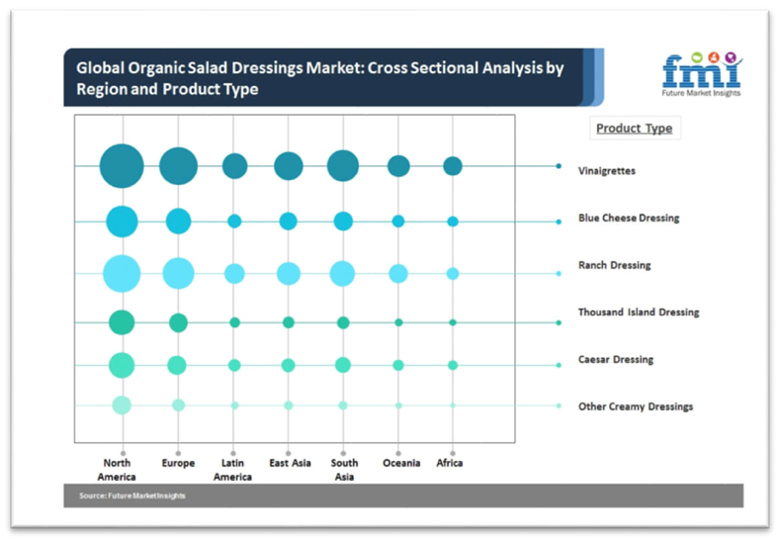
The clean-ingredient salad dressing industry aligns with the current trend of mindful eating by focusing on quality, transparency, and sustainability. With evolving consumer preferences towards cleaner labels and sustainable practices, the industry is poised for continuous innovation and growth. This industry's commitment to clean ingredients and sustainable methods resonates with the modern ethos of conscious consumption, paving the way for its enduring evolution and market presence.

SWOT Analysis
Sloan (2023b) performed a comprehensive SWOT Analysis for Tessemae’s All-Natural, detailing the internal and external factors impacting the brand (see Figure 4). It highlights company strengths, such as brand loyalty and product appeal, while acknowledging challenges, like competition and reliance on digital algorithms. Additionally, it identifies significant opportunities for growth, like health trends, while pointing to potential threats in the digital marketing landscape, like negative feedback. This matrix was foundational for strategic, situational, and alternative analyses.

Figure 4
Vine to Viral: Tessemae’s in the SWOT Matrix
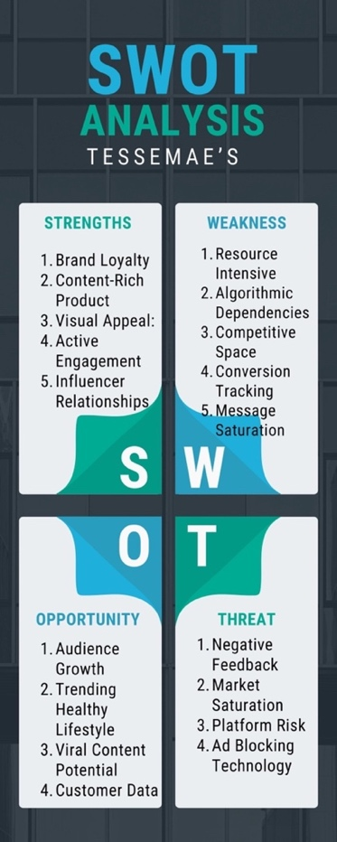
The SWOT Analysis uncovers the strengths, weaknesses, opportunities, and threats within the company’s environment. Strengths include brand loyalty, content-rich products, visual appeal, active engagement, and influencer relationships. Weaknesses are resource intensity, algorithmic dependencies, competitive space, conversion tracking, and message saturation. Opportunities include audience growth, trending healthy lifestyles, viral content potential, and customer data. Threats include negative feedback, market saturation, platform risk, and ad-blocking technology (Sloan, 2023b). Experimenters considered these environmental aspects throughout the situational and alternative analyses.

Client Background
Tessemae's was founded in 2009 by Greg, Brian, and Matt Vetter in Annapolis, Maryland with the aim of creating healthier, delicious, and organic alternatives to traditional condiments (Zax, 2014). What began as an heirloom recipe eventually expanded into a well-known brand available in various stores across the United States (Tessemae’s, 2023). The Vetter brothers started their journey by selling their homemade salad dressing at local farmers’ markets where they quickly gained popularity among health-conscious consumers. Initial success at local stores eventually led to advancement into larger United States retailers, such as Walmart and Target (Prewett & Vetter, 2022). Capitalizing on this grassroots momentum, Tessemae's has effectively transitioned from local farmers’ markets to national grocery shelves, stressing the brand's scalability and the universal appeal of its health-oriented products.
With no company, product, packaging, or fundamental knowledge of the salad dressing industry, Greg Vetter packaged a salad dressing-soaked piece of romaine lettuce in a plastic Tupperware container and took it to the local Annapolis Whole Foods management team for sampling. The Whole Foods liaison expressed genuine interest after merely licking the wet piece of lettuce and saying, “You have something really special here” (DOTCOM, 2022, p. 01). Since then, the family has been fiercely expanding their business toward becoming national top-sellers of organic salad dressing. They have credited their success to their amicability as a family. Vetter stated, “Disagreements are settled through cursing, arm wrestling, foot races, pushup contests, and thumb wrestling. We have found that some of the best ideas come from disagreements, and that is what has made our company what it is today” (Tessemae’s, 2023). From a lick of lettuce to fierce expansion, together, the Vetter family embody the American dream as clean-eating missionaries taking every step with humble gratitude.
Tessemae's is a private company that has experienced noteworthy market growth and brand success across its fifteen years in business; however, financial stability has been inconsistent. Tessemae’s filed Chapter 11 bankruptcy on February 01, 2023 (Tessemae’s, 2023) to restructure accumulated debt, preserve market share and brand equity, and foster longevity (Pitchbook, 2023). Despite the financial challenges necessitating this strategic reorganization, Tessemae’s commitment to quality and established market presence thrusts the company toward a path of profitability and continued brand success. Greg Vetter, CEO (2023), proclaims:
Our goal, from the beginning, was to bring a suite of products into the marketplace to those who believe there is a better way. This decisive action will no doubt enable us to do just that and, in turn, emerge as a stronger, more competitive business. This comprehensive restructuring will enable us to thrive for years to come and enable us to recognize our full potential. The future is bright. (Tessemae’s, p. 01)
Despite facing financial hurdles and undergoing Chapter 11 restructuring, Tessemae's remains buoyed by its commitment to quality and market presence, as reaffirmed by CEO Greg Vetter's optimistic outlook.

Problem
Tessemae's promotional efforts grapple with resource-intensity, algorithm-dependency, and market saturation while seeking to exploit growth using viral content opportunities amid negative feedback and ad-blocking trends. In the tripulant CPG landscape, middleman scarcity incites price sensitivity. Likewise, promotional efforts have become dependent on algorithm favorability, which is a risky investment. As time continues, organic dressing entrants of all sizes continue to offer diversified packaging and niche flavorings. Tessemae’s seeks to cut through the noise and exploit audience growth through viral content, but ad blockers and negative feedback persist as formidable risks. Through a combative internal environment, Tessemae’s fights for market share in a growing rat race.

Target Market
A target market segment was compiled from segmentation, geographical targeting, and motivation. First, the team segmented the market using demographics, psychographics, and geographic targeting. Two market segments arose from this study, including trend-dieters and families. Because of messages conveyed by Greg Vetter, CEO, trend-dieters were chosen as the target market segment. A buyer persona was targeted within the target market segment, creating the serviceable obtainable market (SOM) (Chi, 2023). Using this layered approach to targeting, Tessemae’s can better assist consumers down the purchase funnel.

Segmentation
Tessemae’s primarily targets health-conscious relational value customers who are mindful of clean ingredients and willing to pay a premium for performance parity (Day & Moore, 2011). The team considered many aspects while choosing the target market segment, including demographics, psychographics, geography, behavior, and motivation. Researchers also applied cultural segmentation throughout the process (Belch & Belch, 2021, pp. 134-135). During the segmentation process, experimenters performed both primary and secondary research to detail Tessemae’s target market segment, which is configured below.
Demographics. Analysts used secondhand research to factor demographics such as age, sex, education level, and income into the target market segment. Target adults are health-conscious women aged 25-45 who are wizened about nutrition and wellness (Ureña et. al., 2007). Middle to upper-income consumers ($65,000- $150,000) who can afford premium-priced, all-natural products were also considered (Josephson, 2022). According to Hansmann (2020), higher incomes, social statuses, and education levels have been linked to organic food purchases and clean eating habits. Clean eating tends to be a choice of leisure for the more privileged in income and lifestyle.
Psychographics. Researchers also considered psychographics such as lifestyle, values, political affiliation, generation, and social class. Tessemae’s is a heavily cultural brand that has carved out a customer base of loyal, clean-eating foodies. It targets consumers who lead an active lifestyle, exercise regularly, and are involved in wellness. Individuals who value organic, non-GMO, gluten-free, and clean ingredients in their food are attracted to the copy and promotional structure already intact.
Women in the new era of social politics are three percent more likely to eat healthily than their male counterparts and take a weight-neutral, non-body-dysmorphic, and feministic approach to dieting (Dodier, 2020). Liberal Democrats are more likely to comprise the estimated 33% of clean-ingredient consumers who use dietary restriction trends like pescatarian and vegetarian diets, contrasting traditionally neophobic, conservative Republicans may oppose meat-free, gluten-free, and bare subsistence diets (Guidetti, Carraro, & Cavazza, 2022). Middle-class and upper-middle-class, liberal, millennial foodies of a highly emergent nature (Hoffman, Kopalle, and Novak, 2009) are more likely to understand and appreciate Tessemae’s quality. This data suggests that health-conscious eating trends, including the clean-dressing market, are significantly influenced by gender, political orientation, and socioeconomic status, with liberal, middle to upper-middle-class millennial women emerging as a consumer segment.
Building on the understanding of Tessemae's key consumer demographics, insights into Emergent-Nature Consumers, and lead-Users further define the target market as those who are not only trend-aware but demanding high-quality, innovative products. According to an original essay by Vernette and Hamdi-Kidar (2014), Emergent-Nature Consumers (ENC) and Lead-Users (LU) are customers ahead of market trends and expect high-quality products. They have an eye for tweaking products to perfection and can spot the performers through the market noise. Emergent nature consumers can navigate any market, while LUs specialize in a specific area of expertise. In conclusion, Vernette and Hamdi-Kidar's take on ENCs and LUs reflect Tessemae's target market: quality-focused individuals likely to embrace innovative, clean-ingredient salad dressings.
Geographic Targeting. Information previously uncovered will interpret the geographic targeting of the market. As was unearthed during the market and industry evaluation, the United States is the supreme geographical region for oil-based, clean-ingredient dressing sales (see Figure 3) (Future Market Insights, n.d.). Urban and suburban areas of the United States, where natural and organic products are readily available, lead in popularity.
Similarly, product and branding appeals may be better received by popular regions and states with higher health and wellness focuses. For instance, according to the United States Department of Food and Agriculture (2022), 36% of United States organic food sales and locally sourced organic sales come from California. Urban California, therefore, poses a substantial market coverage opportunity for Tessemae’s regarding supplier and consumer segments. An ideal focal point is the San Francisco Bay Area (Niche, n.d.), where Democrats hold most public offices, and the liberal culture caters to progressive small brands (Anonymous, 2022). Tessemae's strategic market segmentation targets the San Francisco Bay Area, capitalizing on its liberal culture and health-conscious consumer base, positioning the brand for significant traction in this region.
Motivation. Tessemae’s has a wide range of consumers who all coalesce for the cultural enrichment of food; who among them is the most viable segment of motivational focus? Sloan (2023) performed a motivational study to assess Tessemae’s existing customer base by processing Amazon reviewers through Generative Pre-Trained Transformer Four (GPT-4) for a motivational analysis using both psychoanalytic theory and Maslow’s hierarchy of needs. This study utilizes a multimodal large language model and psychological theory to identify the most promising target market segment for Tessemae’s based on socio-emotional food culture.
Researchers processed customer feedback data to gain deeper insights into consumer behaviors and preferences. Open AI's GPT-4 refined the data (see Appendix 2) for a list of post-purchase pros and cons describing a flavor variation of Tessemae’s shelf-stable, organic, creamy ranch dressings. The team then clustered consumers by their respective star ratings for a more nuanced analysis, highlighting patterns in customer satisfaction and preferences crucial for targeted marketing strategies and product development initiatives. The honed technology categorized consumer feedback by star ratings, providing Tessemae's with valuable insights into customer preferences and satisfaction.
Experimenters utilized advanced AI analysis by evaluating Tessemae's customer base through the lens of Maslow’s hierarchy of needs and psychoanalysis, revealing a target market prioritizing health, wellness, and self-actualization. The multimodal large language model processed Tessemae's customers through Maslow’s hierarchy of needs while simultaneously psychoanalyzing them for motives (see Appendix D). Tessemae’s seems to focus on consumers who do not just look for salad dressings but a healthier, cleaner, and more natural alternative to conventional condiments. This focus on health and wellness aligns with the higher tiers of Maslow's pyramid, suggesting that Tessemae’s is adept at catering to the evolving self-actualization desires of its conscious, holistic consumers.
Tessemae's consumers meet their basic physiological needs for nourishment and health when they consume fresh produce. Consumer preferences for a safe, ethical, and quality shopping environment emulate their specialty shopping habits. Natural foods also align with safety needs because they are healthier, less processed, and contain fewer additives, pesticides, and preservatives that could pose ecological and anatomical risks. Further, clean-ingredient, organically sourced, and palatable condiments can be shared with family and friends, fostering socioemotional connection, and spreading social good. Purchasing premium, all-natural products from specialty stores can improve social status and esteem. Therefore, consuming Tessemae's-topped salads and fresh produce elevates reflective self-worth because of healthy lifestyle choices. To conclude, Tessemae’s customers align their shopping and consumption habits with their conscious eating values, suggesting they are moving towards their full potential, ultimate personal growth, and self-actualization.

Target Markets of Interest
This research identifies two primary stakeholder groups for Tessemae's market focus: diet-specific consumers and families, especially those with millennial mothers and Generation-Y daughters, which are crucial to the retail sector (see Appendix 4). The primary segment is the “diet-specific consumers” (~33.33% of the organic salad dressing market) (Amick, 2018), and the secondary market segment is “families” (81% of families are at least partially eating organic) (Haumann, 2013). Families with powerful mother-daughter bonds are also a dynamic of interest. According to Hoover and Haytko (2007), “the mother-daughter relationship is the mainstay of the retail industry” (p. 02). This analysis pinpoints two vital market segments for Tessemae’s, each with distinct influences and purchasing patterns.
Tessemae's will focus on diet-specific consumers and family-friendly products, aligning with its unique value proposition of catering to clean dietary preferences. Diet-specific consumers follow distinct diets, like Whole30, gluten-free, vegetarian, etc., because Tessemaes' value proposition caters to these diets (Urban, 2016-Prewett & Vetter, 2022). Because of Tessemae's kid-friendliness, families with young children might also be a significant focus. Tessemae's strategic marketing approach effectively targets diet-specific consumers and families, aligning offerings with family-friendliness and diet trends to tap into segments.

Buyer Persona
Researchers compiled a SOM using a unique buyer persona representing one to five percent of the Bay Area organic salad dressing market. In consonance with the motivational study by Sloan (2023), further psychoanalysis suggests that the ideal consumer is both psychologically and motivationally complex with multifaceted behavior motivated by a range of needs from basic physiological sustenance to higher-order needs of esteem and self-actualization (Belch & Belch, 2021). Their relationship with Tessemae’s products is not merely transactional but intertwined with a broader ethos, painting a holistic mural of a conscious, value-driven, high-emergency consumer. The salad dressing industry has seen exponential growth in recent years and is forecasted to continue this upward trend.
Projected market growth indicates a promising future for the salad dressing industry, presenting Tessemae’s with a substantial opportunity to capitalize on this expanding market. As evidenced by consumer motivations and industry forecasts, the salad dressing market is forecasted for notable growth (Future Market Insights, n.d.). According to Clare (2023), “the salad dressing market size is expected to grow from USD 75.51 billion in 2023 to 98.54 billion by 2028, at a CAGR [compound annual growth rate] of 5.47% during the forecasted period [2023-2028]” (p. 01). Globe News Wire projected the salad dressing market to grow to USD 98.54 billion by 2028, presenting opportunities for robust market expansion.
The motivational study, surveys, and customer insights comprise the buyer persona Tessemae's will use as the SOM. The selected buyer persona describes a middle-class to upper-middle-class, college-educated, neophiliac, liberal Democrat (Hoover, 2007-Guidetti, Carraro, & Cavazza, 2022). This buyer is a San Francisco Bay area millennial female, aged 25-45, making $65,000- $250,000 in annual household income, and identifies as a clean-eating foodie (Ureña et. al., 2007-Gorynski, 2023-Josephson, 2022-Anonymous, 2022-Prewett & Vetter, 2022). She enjoys campy maximalism and desires to fit into groups and belong (de Guzman, 2022). The VALS-2 Segmentation Model describes her as an “experiencer” (12% of the population) or free-will consumer who enjoys experiencing new things (Vaidyanathan, 2008). She has been affectionately named Sophia Greenwell (see Appendix 5). Sophia is a nuanced character representing an estimated one to five percent of the Bay Area organic salad dressing market and will contrive Tessemae’s SOM.
Researchers forged a buyer persona with the help of a multimodal large language model, expert insights, and market sensing. Analysts used artificial intelligence (AI) to illustrate Sophia Greenwell as a humanistic customer example and scrutinized her likeness during the targeting, segmentation, and motivational studies (see Figure 5) (Sloan, 2023b). They then uncovered insights and entered them into a video engendering GPT for a video sample of what Sophia may look like, how she may behave, and visual discernment of her motives. Although the GPT illustrated her as a Caucasian woman here, researchers have adopted a pluralist racial segmentation for Sophia. She could be a documented or undocumented American of any race, religion, or ethnicity (Lavin, 1996). This innovative approach to creating a versatile buyer persona embraces diversity and inclusivity, signifying a paradigm shift in market research and offering a more comprehensive and empathetic understanding of the varied consumer landscape.

Figure 5
Sophia Greenwell: The Clean Condiment Connoisseur
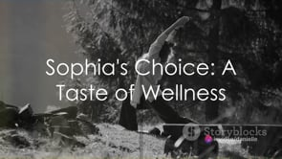
Note. Meet Sophia Greenwell, the ideal campaign customer. First, a video monologue will play (Sloan, 2023b).
Sophia pivots on her physical and emotional well-being through aspirations of fitness and quality food choices, disdaining unsustainable products with short life cycles (Goldman, 1982), diligently reading product labels, and actively seeking healthier options. With a neophiliac lease on dieting, she keeps constant updates on new niche diet trends (Prewett & Vetter, 2022). Her family-oriented nature ensures preservation of the unbreakable bonds between her and close confidants, which satiates her mature socio-emotional needs and fosters her desire for closeness (Tessemae’s, n.d. b-Belch & Belch, 2021). She also participates in coming-of-age subcultural activities, like social media trends and climate efforts, and enjoys the sense of belonging afforded by these groups. Her socio-ecological perspective on eating is complex, conscientious, and sustainability-focused (Kitunen, et. al., 2019).

Competition
Despite domineering salad dressing oligopolies, Tessemae’s has prevailed, maintaining a decisive market presence amid economic challenges, internal power struggles, and fiscal hardship. Consumer packaged goods mega-oligopolies, which constantly diversify into new adjacencies, control a significant market share within the salad dressing industry. While weathering the evoked set (see Figure 6), Tessemae’s has shown impressive growth, especially during the recent economic crisis. Its estimated net worth was approximately two billion dollars in 2013 (Henderson, 2013), and although its 2023 valuation is unknown, its annual revenue stands at $16.3 million (Pitchbook, 2009). Tessemae’s, with its impressive growth trajectory and substantial market presence, continues to be a competitive player in the salad dressing industry, evidenced by its significant annual revenue and robust valuation over the years.

Figure 6
The Evoked Set: Maintaining Competitive Advantage in a Cycling Market
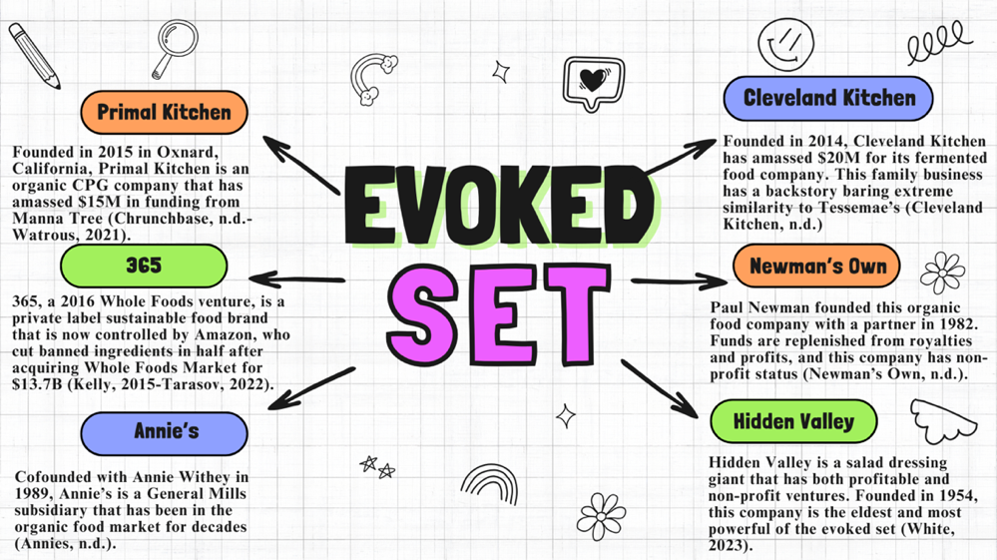
Note. Sloan and Faison (2023) have compounded a well-rounded evoked set from consumer surveys.
Facing stiff competition from established players with extensive industry histories, Tessemae’s strategically focuses on hiring millennials, aligning with its brand culture, and leveraging their insights for its progressive expansion. Tessemae's insists on hiring millennials because they fit the brand culture and have diligently kept abreast with progress (DOTCOM, 2022). However, conglomerates wield a competitive advantage over Tessemae’s through extensive industrial histories. Despite the competitive advantage held by its more established rivals, Tessemae's commitment to its millennial workforce assembles a unique brand loyalty, forms a specialized understanding of its target market, and carves a distinct niche into the industry.
Tessemae’s also faces competition from several other condiment brands, especially those focusing on clean eating options, like Cleveland Kitchen. Cleveland Kitchen is another bro-owned brand known for its fermented products, particularly its line of sauerkraut. Founded in 2016 by Drew Anderson and Luke Visnic, the Cleveland, Ohio-based company offers healthy, probiotic-rich, and flavorful fermented foods to promote gut health and overall well-being (Cleveland Kitchen, 2023). Products include sauerkraut flavors and fermented salad dressings. Their ingredients focus on a natural fermentation process that creates probiotic-rich foods.
However, there are many differentiations between the two companies, particularly in fiscal configurations and funding structures. Though Anderson, Anderson, and Visnic founded Cleveland Kitchen six years after Tessemae’s, in 2014, they have vastly surpassed it in funding. Backed by venture capitalists, it stands among the highest-funded companies in the organic salad dressing industry. The Anderson-Visnic siblings, Drew, Mac, Emma, and Luke, grew up working with farmers sourcing organic ingredients for their mother, Donita Anderson, a Biologist and Chef who founded the North Union Farmers’ Market in Northeast Ohio (Cotton, 2023). The contrasting financial trajectories of Cleveland Kitchen and Tessemae's highlight the varied strategies within the organic salad dressing sector.
Cleveland Kitchen's strategic alliances with key investors threaten Tessemae's fiscal well-being. From their farm connections, they united with Amberstone, a Venture Capitalist (VC) firm in the CPG space, and Chiel Jedang (CJ) Group, one of the largest Korean international conglomerate-holding companies in Seoul (Ortenberg, 2022). These firms led to investments into Cleveland Kitchen from Clover Vitality and Cabbage Inc., one of the largest cabbage investors in the world, for $20 million in two rounds of funding (Cleveland Kitchen, 2022). In contrast, Tessemae’s has accumulated five million dollars in a single round of funding from two investors (Tracxn, 2023), Sagamore Ventures LLC, the VC arm of Plank Industries (Tessemae's, n.d.), and War Horse Ventures (Tracxn, 2023). Plank Industries is owned by Under Armour CEO Kevin Plank (Tessemae's, n.d.). Although Cleveland Kitchen has surpassed Tessemae’s funding, the Vetters remain deadlocked on their success path.
Cleveland Kitchen and Tessemae’s also differentiate in market coverage strategy. Cleveland Kitchen has been exclusively found in select, specialty, and health food stores until 2020, helping it acquire its health-conscious target market segment (Miller, 2020). However, it can now be found in Kroger, Publix, Target, and Walmart, increasing brand coverage to mass markets. Early narrow segmentation and later expansion to mass marketing allowed Cleveland Kitchen to capitalize on the customer as an asset, pushing its brand equity above that of Tessemae’s.
Company focuses are also at odds as both companies are committed to healthier, cleaner ingredients but differ in core product offerings and specific approaches to achieving objectives. Tessemae's focuses on an eclectic range of five-ingredient and shelf-stable condiments and dressings. Cleveland Kitchen specializes in fermented foods, particularly sauerkraut and probiotic-rich fermented dressing. This diversity in focus and specialization allows each company to carve out its niche in the market, catering to specific consumer demands and contributing uniquely to the growing trend of healthy eating.
New entrants are not the only threat to Tessemae’s market share, more established brands wield even more authority. Another contender is Newman’s Own, a food company widely recognized for its extensive range of food products, particularly dressings, sauces, snacks, and other pantry items. The company was founded in 1982 by the acclaimed actor Paul Newman and his friend, A.E. Hotchner. Newman’s Own has capitalized on the brand as an asset, but what differentiates it from other brands is its cause marketing commitments to various charities (Newman's Own, 2023). Compared to Tessemae's focus on clean ingredients and health-conscious products, Newman’s Own differentiates itself in the food industry with an eclectic product range and a pledge to cause marketing, or when a nonprofit organization and a for-profit company collaborate for a common benefit via marketing campaigns (Mailchimp, n.d.). In the landscape of health-conscious food brands, Tessemae's maintains its distinct position with clean, simple ingredients, contrasting with Cleveland Kitchen's fermented focus and Newman’s Own's diverse range and cause marketing endeavors, demonstrating the varied strategies employed by companies to carve out their niche in this competitive sector.
Newman's Own has gained popularity for the quality of its products and unique business model. Its value-creating system includes post-tax donations of profits to charities, which resonates with its altruistic consumer base. Its continued growth and success are closely tied to its commitment to quality products and cause marketing. Business model and marketing alignments with charities like FoodCorps and the Serious Fun Children’s Network accelerate Newman’s value-capturing system (Newman’s Own Foundation, n.d.). Newman's Own sets itself apart in the market with its blend of quality products and philanthropy, presenting a unique competitive stance compared to Tessemae's focus on clean ingredients and health-conscious offerings.
Highlighting its unique business model, Newman's Own achieved significant revenue in 2020, reinforcing its animating principle by donating all surplus earnings to various causes and appealing to altruistic consumers. In 2020, Newman’s generated 24.6 million dollars in revenue, with expenses of 16 million dollars. Any surplus ($7.6 million) was donated to charity (ProPublica, 2023), emphasizing its niche as a charitable nonprofit. The easily achieved altruism appeals to conscious consumers. This philanthropic approach sets Newman's Own apart in the market, contrasting with Tessemae's emphasis on health and organic ingredients by attracting consumers who prioritize social impact in their purchasing decisions.

Objectives
The SMART Model was used to identify communication objectives that are specific, measurable, attainable, relevant, and time-bound (Emergency Communication Preparedness Implementation Kit, n.d.). The communication objectives administer a prescribed growth trajectory that speaks to the marketing mix while strategizing with the overall integrated marketing communications (IMC) program.
This comprehensive strategy outlines ambitious objectives for Tessemae's in the coming year, focusing on significantly boosting Instagram engagement, enhancing social media conversion rates, and optimizing the online purchasing process to achieve remarkable growth in both follower count and customer conversion. According to Sloan and Faison (2023) the communication objectives are as follows:
- Tessemae’s will increase brand awareness by 28.57% through Instagram engagement in the next year.
  - Since the annual projected growth of the organic salad dressing industry is 460.6% (rounded to ~ 461%), a 400% annual growth possibility for Tessemae’s Instagram follower count can be safely predicted (Clare, 2023).
  - Four hundred percent growth of Tessemae’s 144,000 followers, equals ~ 41,144 new followers YOY (year over year).
  - Tessemae’s is near the top of the bell curve regarding company growth in the organic salad dressing industry, so this is an achievable yet ambitious growth objective.
    - 41,144 followers are 28.572222222222% (rounded to ~ 28.57%) of Tessemae’s 140,000 Instagram followers, so by the end of this plan it should have roughly 180,000 Instagram followers (Tessemae’s, n.d.).
- Tessemae’s will increase conversions to a stable five percent across social media pages within one year by implementing a strategic and functional social media funnel (called the “flavor funnel”).
  - According to Dash This (2023), two-to-five percent of all social media engagers convert. In fact, five percent is an extraordinarily successful conversion rate that is normally achieved using methodological tools and strategies.
  - The social media funnel will siphon social media (Instagram, Pinterest, and Facebook) prospects toward the official website’s point-of-purchase.
    - The official website does not have a viable point-of-sale (POS), so it is imperative that one be outfitted as soon as possible.
      - The more steps required for purchase, the higher the bounce rate. If the conversion funnel is shortened, the bounce rate will decline. The optimal bounce rate is 26%-40% (Jennifer, 2022).
      - The POS consideration set includes Lightspeed, Shopify, and Toast (Top10, 2023), with Shopify showing favorability.
  - Stable is defined as holding a constant five percent conversion rate for one month.
    - There is a 0.5% flexibility contingency regarding this metric.
- Tessemae’s will increase the follower growth rate to a stable five percent within the next year.
  - Stable is defined as holding a constant five percent conversion rate for one month.
    - There is a 0.5% flexibility contingency regarding this metric.
  - Objective success is measured by follower growth metric fluctuations and is expressed as a percentage.
    - Metrics will be extracted from all social media pages using social media analytics, Google Analytics, and social media APIs. (Macready, 2022-Kataras, 2023-Rapid API, n.d.) (see Figure 8).
In sum, these well-defined SMART goals will convey Tessemae's as a digital nomad, aiming for measurable accomplishment in online engagement and exponential conversion growth across channels.

Strategy
In the strategic landscape, Tessemae’s airs a revolutionary approach to enhancing brand visibility through NIL deals, a hashtag campaign, a social media marketing funnel, and disruptive product innovation; this four-pronged approach is to resonate with the health-conscious demographic of women aged 25-45 who champion clean-eating and organic choices by engaging them through Instagram, Facebook, and Pinterest. With the introduction of the #IGotTheSauce hashtag, athletic partnerships, and differentiated package sizes, the brand will enter a new era of engagement and connectivity.
The campaign will feature the same campy maximalist tone as Tessemae’s current website content, white bolded Calibri Body fonts, and loud color schemes like those on the landing page. The campaign slogan is “Game On,” and serves as a rallying cry for female athletes, trend-dieters, and clean-eaters. With its bold and engaging aesthetic, the Game On: Clean Meets Cuisine campaign captivates and unites a diverse community of health enthusiasts, seamlessly blending Tessemae's spirited branding with innovative marketing approaches to create a powerful foodie movement.
Female college athletes and micro-influencers representing the Bay Area will push Tessemae’s new line of purse and pocket-sized sauces using the branding material, particularly the #IGotTheSauce hashtag, currently at 17,477 Instagram posts. The #IGotTheSauce hashtag has the potential to become a massive social media optimization (SMO) keyword that could transcend the brand to new levels of marketing disruption. The flavor funnel will catalyze trending efforts, which invite conversions and exacerbate customer interactions toward sales. Embracing this innovative blend of campy maximalism, athlete-driven enthusiasm, and social media savvy, Tessemae’s stands to redefine the digital marketing landscape. The #IGotTheSauce hashtag, micro-influencer NIL deals, the social media “Flavor Funnel,” and new product innovations drive the brand further into new terrain.
Tessemae's effectively uses social media platforms for brand promotion, tailoring its approach to the unique features of each channel. Tessemae’s utilizes Facebook for engaging content and storytelling, Instagram for visually appealing posts and recipe videos, and Pinterest for recipe pins and affiliate links. Strategies and sponsor-based ads enhance brand visibility and audience engagement (see Table 1).

Table 1
Social Media: Usage Demographics by Platform (2023)
Social Media Platform | Age Group | Percentage/Number of Users | Source | Content and Strategy | Purpose and Effectiveness
Facebook | 25-34 | 25.7% | (Herd, 2023) | Engaging blog content, healthy eating tips, behind-the-scenes stories | Connects through storytelling, educates on health and brand values
Facebook | 35-44 | 18.1% | (Herd, 2023) | Same as above | Same as above
Instagram | 18-29 | 71% | (Dean, 2023) | Visually appealing content, recipe videos, user-generated content, influencer partnerships | Displays product use, leverages visual appeal and influencer reach
Instagram | 30-49 | 48% | (Dean, 2023) | Same as above | Same as above
Pinterest | 18-34 | 32% | (Oberlo, n.d.) | Recipe pins featuring dressings, affiliate links | Inspires usage in various meals and diets and facilitates direct purchases

#IGotTheSauce Hashtag
The brand can use trending audio, reels, keywords, and hashtags to boost consumer engagement across platforms. For the target market segment, it is suitable for the Game On campaign to introduce the #IGotTheSauce hashtag. This hashtag, using the 44 Ps of marketing (Sandeen, n.d.), applies benefits and attributes positioning to emphasize Tessemae’s use of natural and organic ingredients as the value proposition (Belch & Belch, 2021), and removes limitations from product uses, whether as a marinade, sauce, dip, ingredient, or otherwise. By adding just, the right amount of sexuality, culture, and comedy to the already hip brand, Tessemae’s accentuates its versatility. The brand will also convey the hashtag in a way that underlines the commitment to sustainability and healthy living (Macready, 2022). By leveraging the dynamic and culturally relevant #IGotTheSauce hashtag, Tessemae's enhances the brand appeal, emphasizes commitment to natural ingredients and versatile usage, and aligns with contemporary sustainability and healthy lifestyle trends.
Brain chemistry, behavioral economics, customer insights, and popular culture inspire the Game On campaign. People gravitate to media because of activation in the pleasure responses in their brains. The brain is a complex machine that drives decision-making, sometimes to the point of baffling cognition researchers (see Figure 7). Sapolsky (2023) published a controversial finding in his book Determined: The Science of Life Without Free Will that humans may have little to no free will due to hormones, gut enzymes, and bacteria that drive autonomic reactions to stimuli. As behavioral economists gain interest in this topic, it expeditiously gains marketing popularity. As marketing, business, and media entertainment disciplines become progressively more scientific, contemporary art utilizes pleasure centers in the brain. Considering that, the Game On campaign leverages brain chemistry and neuroeconomics, tapping into the target market and its existing media preferences and exploiting the science behind decision-making and emotional responses for strategic marketing efficacy.

Figure 7
Feeding Desire: Naïka’s Sauce Video (2021)

Note. Naïka’s song “Sauce” (2021) quickly amassed nearly five million YouTube views, reiterating the importance of food and sexuality within a civilized human culture that dates to the Roman empire (Grozanik, n.d.).
Recent studies reveal that the mid-anterior orbitofrontal cortex, a crucial component of the frontal lobe, activates during experiences of intense enjoyment, such as eating a delectable meal, listening to sensual music, or experiencing an orgasm. The same part of the frontal lobe that lights up magnetic resonance imaging (MRI) during orgasm also lights it up when the brain senses a tasty dessert like chocolate or sensual music like Enya (2009). This illuminated section of the brain is the mid-anterior orbitofrontal cortex, the portion of the brain just beneath the forehead. According to a dual research fellowship team at Oxford University, this emotion-controlling piece of the brain is responsible for pleasure-seeking responses and behaviors (Wood & Kringelbach, 2009). The emotions felt while viewing Figure 7 are highly controlled chemical reactions hardwired within the executive functioning of the brain's frontal lobe (Neurotheology, 2023). The orbitofrontal cortex's role extends beyond its structural position in the brain, revealing its profound involvement in human emotional and sensory experiences.
The Orbitofrontal Cortex (OFC) stands out as a crucial area within the prefrontal cortex, intricately linked to emotional responses and memory processing. The OFC (see Figure 8) is the outermost layer of the brain, where the parietal lobe and temporal lobe meet, lying just below the skull bone of the human forehead. It is an area of the Prefrontal Cortex (PFC) that sits just above the orbits (eye sockets) at the very front of the brain. The OFC also has extensive connections with the limbic system structures involved in emotion and memory (Vox-Pol, 2016). The mid-anterior part of the OFC is the front and center portion just beneath a person's fingers if they place them onto their top, center T-zone about an inch below their natural hairline. One of the coinciding limbic systems to the OFC is the thalamus, within which is the medial dorsal nucleus, which sends sensory projections to the orbitofrontal cortex involving emotion, taste, smell, and reward in decision-making (DeeFeeCee, 2023). In conclusion, the OFC is responsible for a fundamental range of human responses and decision-making processes, encompassing basic sensory perceptions and intricate emotional and reward-based reactions.

Figure 8

Unlocking Human Motivation with the OFC
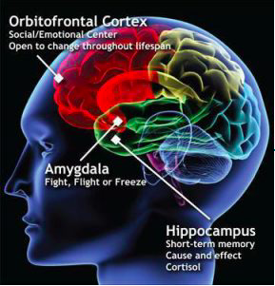
Note: This map shows the brain’s emotional centers in a color-coded fashion (Dingman, n.d.). The frontal lobe, shown in red holds the OFC. The OFC is not fully developed until roughly age 25 (Arain, et. al., 2013) and is the basis of new concepts, such as socio-emotional learning (Beer, et. al., 2006). The anterior OFC is the frontal outermost layer of the brain below the labeling dot.
Understanding the intricate functions and impacts of the OFC lays the groundwork for exploring its significance in consumer behavior and decision-making, particularly in neurology, behavioral economics, and marketing. According to a neuroeconomics study by Smith and Huettel (2010), sufferers of OFC damage have lowered instances of risk aversion, suggesting that those with a healthy OFC make more mature, informed, and risk-averse decisions. This comprehensive overview of the OFC underlines its critical role in emotional processing, sensory integration, and decision-making. Smith and Huettel’s (2010) work in neuroeconomics further italicized its impact on risk assessment, informed decision-making behaviors, and the importance of neurology in marketing. This exploration of the OFC highlights its crucial role in processing emotions and decisions, shedding light on its significant influence in neuroeconomics and marketing and underlining the importance of neurological insights in buyer behavior.
Comprehending cognition is a pinnacle of this campaign because Tessemae's can harness these neurological responses for marketing power. The core aim of the Game On campaign is to speak to prospects through the technology they all currently employ, phones, computers, and brains—which is arguably the most influential technology of them all. In the realm of modern marketing, this insight proves invaluable. Food, much like sex, is an inherently sensual experience. It is a nutriment journey that begins with preparation and culminates in consumption. Both indulgences transcend cultural and personal barriers, resonating universally across races, genders, and sexualities. Leveraging this universal appeal in marketing strategies creates content that captivates and connects with diverse audiences on a fundamental sensory level. This approach orients the brand as a provider of products and a curator of rich, indulgent experiences that appeal to the primal senses and desires inherent in all living beings.

The Flavor Funnel
Researchers have transformed Tessemae's social media approach with the "flavor funnel," designed to streamline the customer journey and enhance purchase efficiency. Sloan and Faison (2023) rebranded Tessemae's nonexistent social media funnel into the “flavor funnel” because it pushes the social media audience through a shortened customer journey from endorsement, post, or promotion to point-of-purchase. The key is to shorten the customer journey, lowering bounce rates, cognitive dissonance, and opportunities for confusion or distraction. The "flavor funnel" will expedite the customer journey and minimize indecision.
Tessemae’s social media strategy will be outfitted with funnels on its Instagram, Facebook, and Pinterest pages (see Figure 9). At the tip of the flavor, funnels will be the POS, which will be equipped directly on the landing page. This POS will send payments to Tessemae’s Amazon store (Tessemae’s All-Natural, n.d.), granting instantaneous drop shipping capabilities. Tessemae’s will lower bounce rates, increase conversions, and accommodate customer ease by effectuating the POS-topped flavor funnel.

Figure 9
The Flavor Funnel: Shortening the Customer Journey
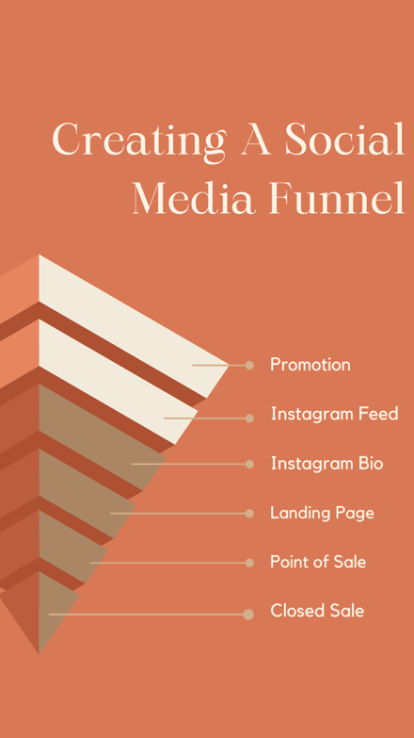
Note. This is the Tessemae’s flavor funnel. Instagram is one example, but it will also be adapted and used for Pinterest or Facebook, achieving the same desired effect.
Tessemae's innovative approach to digital marketing harnesses the power of social media platforms to streamline the customer experience. Tessemae's social media strategy involves tailored funnels on Instagram, Facebook, and Pinterest, leading directly to a POS on the landing page for seamless transactions and drop shipping capabilities through the Amazon store. This shortened customer journey from promotion or endorsement to closing stages will effectively curate bounce rates by enhancing conversions (Sloan, 2023c). To sum up, Tessemae's integration of social media channels with a direct-to-consumer model exemplifies a forward-thinking e-commerce approach, effectively bridging the gap between online engagement and sales conversion.

NIL Deals: Female College Athletes
Name, image, and likeness deals, which lead to increased revenue, brand awareness, and partnership opportunities, are well suited for Tessemae’s Game On campaign. Name, image, and likeness deals help smaller companies capture customers by spreading awareness through social media posts and meet-and-greets (Zielinski, 2023). These deals are also beneficial because they increase brand awareness among target consumers. Likewise, partnering with Bay Area female college athletes can significantly increase brand exposure, especially among younger millennial and older Gen-Z demographics. Athletes often have substantial social media followings, and their endorsements can introduce a brand to a broader audience. In essence, leveraging NIL deals offers an innovative path to fostering connections with salient demographics while amplifying brand reach through platforms of athletic trend directors.
Athletes often have a specific fan base that aligns with their sports, demographics, and personal brands. Their fans and enthusiasts often fall into demographics well within the chosen target market of trend dieters and the Sophia Greenwell persona. Businesses can leverage these target audiences for more effective marketing. For example, a brand could partner with a female college athlete known for sportsmanship and healthy lifestyle choices to leverage her trend-dieting female fan base. Likewise, according to a study by de Borja (2021), “according to 134 athletes who reported following only one diet, the most common practices were: low-carbohydrate (29.8%), vegetarian (22.5%), dairy restrictive (22.5%), gluten-free (14%), vegan (6.7%), and pescatarian (4.5%)” (p. 15). Further, 23.4% of studied female athletes aged 15-30 claimed to adhere to specific diets without medical necessity (de Borja, 2021). Leveraging the fan bases of athletes, who often align with trend diets and health-conscious lifestyles, presents a strategic opportunity for businesses to target and engage with niche markets, as evidenced by the dietary preferences of athletes and their followers.
In the realm of athlete endorsements, strategic selection is based on athletic value, influence, and alignment with brand values. Deals are rated by athletic value and based on influence. A D1 national championship football player with over one million Instagram followers would have a higher rating than a D3 track athlete with only 500 followers. The span of athlete choices gives many companies leeway on endorsement prices. Finding the right athletes for NIL deals involves considering brand values, target audience, and objectives.

Table 2
Strategic Steps for Establishing NIL Partnerships
Respective Steps in the NIL Partnership Process | Description and Actions
Define Objectives and Target Audience | Articulate the marketing goals of the NIL deal & understand the target demographics that resonate with the products, guiding the search for athletes whose personal brand aligns with the target market.
Research Athletes | Conduct in-depth research on potential athletes, focusing on personality, values, & online presence, not just athletic performance. Assess their social media following, engagement rates, and content style.
Consider Local and Regional Ties | Seek athletes with strong connections to specific local or regional target markets. Local ties can enhance the authenticity & relatability of the partnership.
Assess Social Media Influence | Evaluate athletes' social media impact, considering the size of their following & engagement levels. Determine if their content aligns with the brand image and values.
Review Athletic Performance and Image | Consider athletes’ performance and public image, as success and positivity in their sport can add credibility to Tessemae's brand.
Collaborate with Sports Agencies | Work with sports agencies and talent management firms, which represent various athletes, to ease the process of finding and negotiating partnerships.
Utilize NIL Platforms and Agencies | Use NIL-specific platforms & agencies for connecting with college athletes seeking partnerships & streamlining the negotiation. and collaboration process.
Engage with College Athletic Departments | Build relationships with college athletic departments for insights into athletes interested in NIL deals (Green, 2021).
Attend Sports Events and Competitions | Attend events & games to identify athletes with passionate fan bases & popularity among spectators, offering live insights into their influence (Green, 2021).
Reach Out Directly | Contact potential athletes or their representatives to discuss the benefits of the partnership & its alignment with the athlete's brand.
Negotiate Terms and Conditions | Collaborate with the athlete or their agent to agree on compensation, obligations, & partnership scope, ensuring a clear mutual understanding of expectations & deliverables.
Compliance with Regulations | Adhere to NIL regulations (Finck, 2021).

Purse-Stable Picantes (Limited Time Only)
Tessemae’s will drop a limited-time-only line of pocket-sized hot sauces this year and use the Game On campaign to push them to the target market segment. The brand has seen exponential growth during times of “big i" innovation, like when it expanded the flavor profile and dropped its shelf-stable, creamy, organic ranch dressings. It only seems reasonable to vie for a third attempt at this growth structure, hoping to pull the company out of financial hardship and back into well-deserved prosperity. This time, the “big i" innovation will be customized package size for target market suitability. The bottle size will be shrunk to precisely two to 2.5 ounces (or about twice the size of an airplane bottle) (see Figure 10) and according to Fuego Spice Co., an organic habanero sauce can be made from carrots, water, vinegar, habaneros, sea salt, cayenne, paprika, garlic powder, onion powder, guar gum and sweetened with dates (n.d.). The actual bottle design may vary, but for nostalgia purposes, it would be conducive to loyal customers if the brand brought back the original wax-sealed bottles and shrunk them down to trinket size.

Figure 10
The Secret Sauce: Tessemae’s Organic Purse-Stable Hot Sauce Line
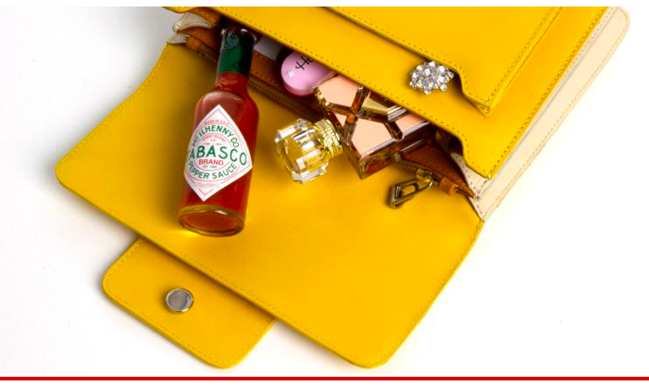
Note. This photo by Zak (2016) in a New York Post article discusses the phenomenon of women carrying hot sauce in their pocketbooks. According to an original essay by Sharp (n.d.), black southern women have a history of necessity carrying hot sauce on their persons. Throughout this process, it is paramount to keep entitled homages intact to avoid instances of racial misappropriation and insensitivity.
Exploring the rising trend of hot sauce as a must-have accessory among influential women, from celebrities like Beyoncé Knowles to political figures like Hillary Clinton, reveals its growing cultural and dietary significance today. What do Hillary Clinton, Beyoncé Knowles, and 61/167 Redditors voting yes or no on a poll from @Deadhoe9 (2021) have in common? Hot sauce has become a staple in many women’s purses. Why should Tabasco have all the fun? According to Zak (2016), hot sauce is chalked full of antioxidants that curb food cravings. Despite not being widely manufactured, mini hot sauces have had increasingly high cultural demands, with Beyoncé quoting. “I got hot sauce in my bag, swag” in her 2016 hit single “Formation” and Hillary Clinton toting it with her on the campaign trail. Although Bey may have used a double entendre in this verse, it still resonates with the masses in its literal form (Tiffany & Grey, 2016). This growing trend highlights a broader cultural shift where hot sauce transcends mere condiment status, becoming a symbol of empowerment and personal style for influential women across various spheres.
Embracing the power of influencer marketing, Tessemae's is set to introduce a new line of compact hot sauces, targeting female consumers through strategic collaborations with micro-influencers and affiliate marketing programs. Tessemae’s will launch a new line of purse and pocket-sized hot sauces for its female segment using athletic yet relatable micro-influencers to market the products with affiliate links for incentive-based outcomes. The brand can even offer affiliate links to participating loyalty members for social discounts (Hughes, 2017) or participants on affiliate link forums like Influenster (n.d.). This innovative approach, leveraging micro-influencers and affiliate programs, positions Tessemae’s to effectively engage and expand its reach within the female market, capitalizing on the growing trend of portable hot sauces.
In conclusion, Tessemae's strategies are to create a flavor funnel, innovate pocket-sized sauces, utilize NIL partnerships with female college athletes, and employ hashtag campaigns. By combining the appeal of influential athletes and the widespread reach of social media trends, the Game On campaign will elevate brand awareness and deepen consumer connections. This dual approach, derived from the versatility and health-focused quintessence of Tessemae's products, actuates the brand to pursue new demographics, fostering meaningful interactions and driving growth in an ever-evolving competitive landscape. With a well-oriented execution strategy, Tessemae's embarks on a transformative path to alter consumer perceptions and interactions, making this brand a staple of healthy, organic eating.

Tactics
Tessemae’s contrives an innovative strategy to capitalize on market coverage, brand recognition, and brand recall. The Game On: Clean Meets Cuisine campaign represents Tessemae's comprehensive strategy to amplify brand presence across Facebook, Instagram, and Pinterest, utilizing micro-influencer partnerships, product innovation, social media funneling, and targeted engagement tactics, like hashtag promotions, to connect with audiences and drive growth in the digital landscape. This multifaceted campaign positions Tessemae's for enhanced market penetration and memorable touchpoints, setting the stage for significant growth and deeper customer connections in an ever-evolving digital arena.

Channel Specific Tactics
Tessemae’s can maximize ROMI by diversifying social media channels for unique purposes. Instagram can be used to interpersonally connect the brand with the SOM, Pinterest can target the specific audience using pins, and Facebook has specialized segmentation capabilities. By integrating social media channels to unique purposes, Tessemae’s maximizes strategy and ferments market coverage.

Instagram
Tessemae’s has a noteworthy Instagram presence that highlights its campy maximalism but lacks content variety and creativity. Upon landing on the Instagram page, viewers see cascades of Tessemae’s bottles in a campy hue (Tessemae’s, n.d.) and posts feature bright, eclectic slideshows of delicious salads, dishes, and dressings. These slideshows are intriguing but become redundant and are better suited for Pinterest, where they are also featured. Therefore, Sloan and Faison (2023) propose a more diverse content focus, particularly on viral trends, stories, and reels that resonate with trend-dieters and Sophia Greenwells (see Figure 11). Considering the observations and recommendations made about Tessemaes’ Instagram presence, it is clear that there is room for improvement in terms of content variety and creativity to engage a wider audience effectively.

Figure 11
Creating Food Cravings on Instagram
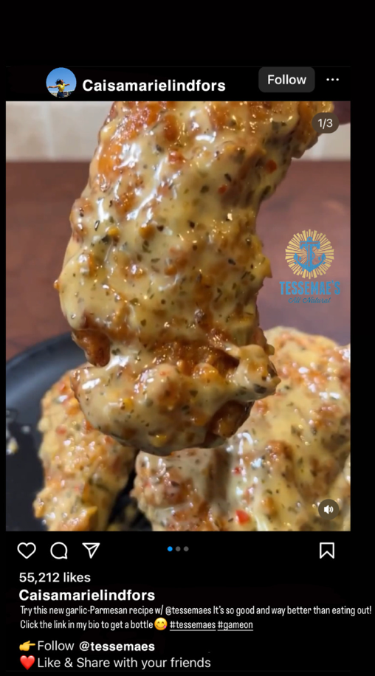
Note. Caisa-Marie Lindfors can share her audience with Tessemae’s using nonchalant buzz marketing for maximum appeal to authority from the trend-dieting, female athletic crowd. Tessemae’s will have a different feel, depending on whose posting it, but it will all coalesce with the watermark (Faison, 2023).
To broaden its market appeal, Tessemae's should focus on creating personal connections between its leadership, like the Vetter brothers, and the audience, as highlighted by the impact of CEO social profiles and personal content on brand engagement. Connecting the Vetter brothers and the Tessemae’s team directly to the audience through content encourages a personal stake in company success. According to the Sprout Social Brands Get Real Report on transparency (n.d.), 63% of respondents say CEOs with social profiles are better representatives of their companies than those who do not, while 64% said posts about a CEO’s family would have a positive impact, and 63% reported the same about a CEO’s personal interests (see Figure 12). By interpersonally connecting with the SOM, Tessemae’s heightens market coverage opportunities.

Figure 12
C-Suite Sneak-Peak Instagram Posts
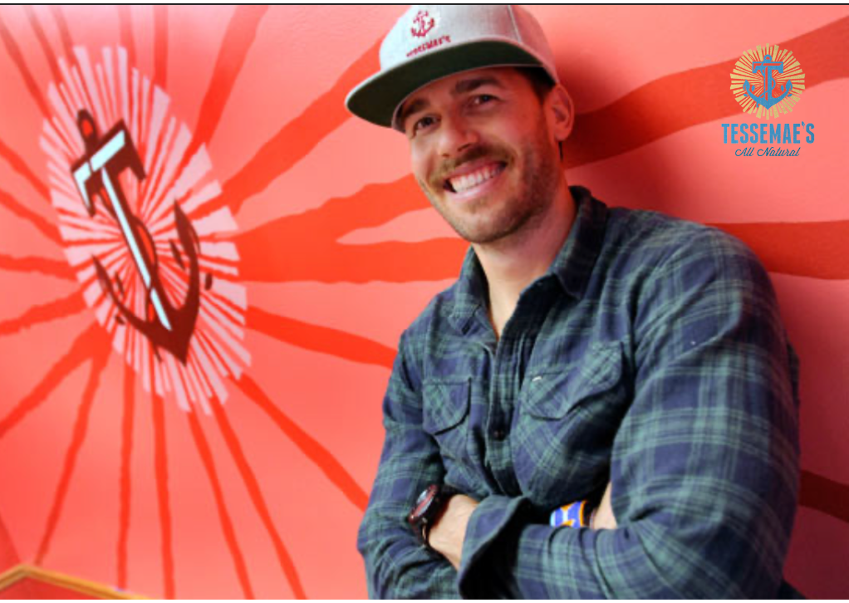
Note. Vetter can mutually capitalize off the brand by building his social influence as CEO. Gaining social media clout will pad the risk in his future endeavors, push Tessemae’s, and create a personalized following for him. He does not appear to have a social media presence, but honing one would promote buzz, trust, and recognition for the brand (Sloan & Faison, 2023b).

Pinterest
Tessemae's must differentiate content by dedicating creators to each channel for tailored posts that match platform ambiance. Similarly, each channel should have a distinguishing purpose; according to Hall (2020), “a one-size-fits-all content strategy never works in social media marketing, and not all content is suitable for every platform.” Tessemae’s posts content on Instagram that is more suited for Pinterest (Tessemaes09, n.d.), therefore Sloan and Faison (2023) recommend that Bigeye employ separate content creators to each channel to diversify content and maximize quality.
Tessemae’s has a strong Pinterest presence, but there are pain points, including low use of social proof and critical SMO tactics. Inspirational storytelling will depict micro-influencers, athletes, and team members' experiences with the brand. Themed boards will include more of the broader, “fat head” keywords and hashtags necessary to funnel mass audiences toward posts (Lynch, 2020). Other important SMO tactics missing from Tessemae’s Pinterest are effective calls to action encouraging purchase funnel progression (Grey, n.d.), clickable purchase links, and brand watermarks to show ownership of created works (see Figure 13). By diversifying channels and addressing pain points, Tessemae’s places a six-inch fold in its already immaculate Pinterest strategy.

Figure 13
Innovative, Simple, and Sharable Pins
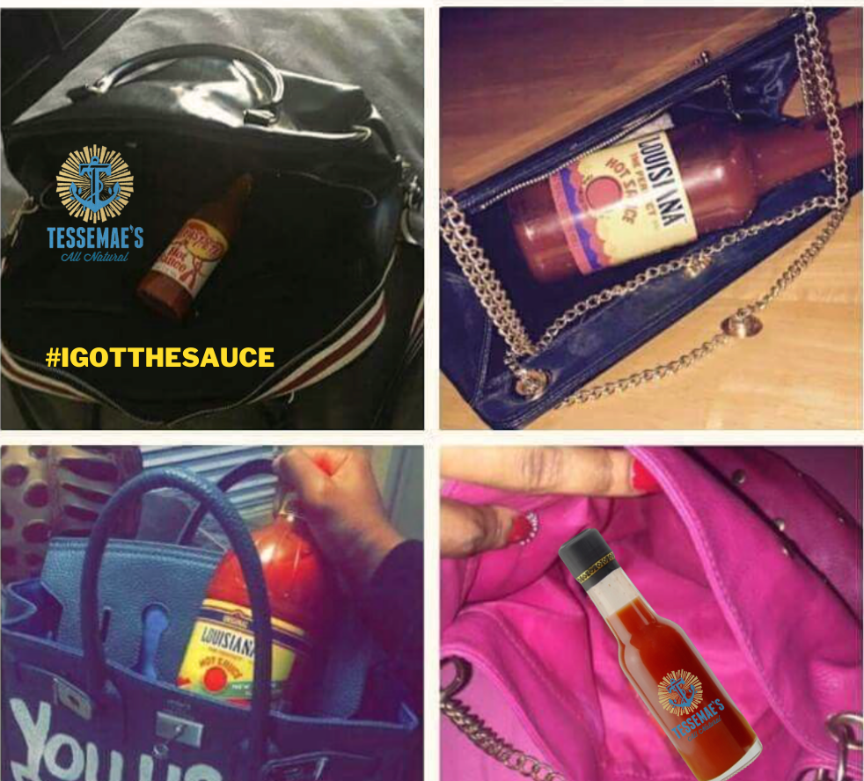
Note. These purse-stable picantes can be pushed using paid advertising on Pinterest (Sloan & Faison, 2023b).

Facebook
Tessemae’s Facebook page features the same content style as the other two pages; in contrast, the brand actively responds to engagement, participates in seasonal marketing trends and utilizes clickable purchase links on the landing page. Nevertheless, pain points exist, some purchase links lead to sold-out products, there are few indications of brand identity, scarce social proof, and content lacks interpersonal feel. Tessemae's can enhance its strategy to enrich content variety, increase social proof, and create a more engaging and personable experience for its audience by addressing these discrepancies. In fact, by refining its Facebook approach to address these issues, Tessemae's can significantly improve user interaction and brand perception, fostering a stronger and more connected online community.
To optimize the customer experience on Facebook, Tessemae's should focus on maintaining updated purchase links to guarantee a seamless user journey. Clickable purchase links are an upgrade from Instagram and Pinterest, but the store contains several sold-out items. Tessemae's should remove sold-out items from the site and replace them with an available product. Regularly updating purchase links and product availability will significantly streamline Tessemae's online shopping process, enhancing user trust and satisfaction on Facebook.
In addition to ensuring product availability, Tessemae's can strengthen its brand identity on Facebook by consistently incorporating clear brand markers, such as watermarks, in its content. Although the #foodporn photos are appealing, for a person scrolling the feed or landing page, indications of brand ownership are exceedingly rare. Brand identity should be loudly apparent on every post using a watermark, proper product placement, and logo placement (Urritia, 2023) (see Figure 14). On a sidenote, the Facebook tagline is incomplete, disjointed, and needs fixing (Tessemae’s, n.d. c). Enhancing brand recognition through consistent visual branding, like watermarks on posts and proper product placement, will reinforce Tessemae's identity, making it more distinct and memorable for Facebook scrollers.

Figure 14
Mock Social Media Post Featuring Athletic Micro-Influencer
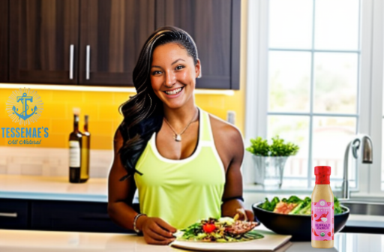
Note. This AI-generated example photo shows the ideal micro-influencer, watermarked logo, social proof, personal touch, and product placement needed to connect with the trend-dieting target market segment and Sophia Greenwell buyer persona (Sloan & Faison, 2023). This elegant, classic authoritative appeal will speak to Berkeley Cal Throws track and field athlete Caisa-Marie Lindfors’ fans by casually alerting them of Tessemae’s existence and quality, for positive, powerful, and persuasive buzz marketing.
Tessemae's strategy to enhance its digital presence involves leveraging social proof through authentic testimonials and micro-influencer collaborations. The brand can leverage social proof by exhibiting real customer testimonials and micro-influencer endorsements to build social media credibility, tapping into the power of social contagion and the bandwagon effect to enhance conversions (Cinelli, et. al., 2020-Optimizely, n.d.). Social media users are often highly skeptical of platform advertisements, but social proof can alleviate some of this paranoia by proving the product’s worth using real customer testimonials and experiences. Using micro-influencers and customers to convey a consensus of brand appreciation and acceptance will cause an echo chamber of cycling social contagion within the flavor funnel, upping conversion via the bandwagon effect.
Adding a personalized human element is crucial in the algorithm-driven landscape of AI, particularly in a platform designed for social interaction. Having some photos of humans enjoying these delights will perform at a higher capacity than solely pictures of food. According to a study by Kelly (n.d.), images showing body parts (i.e., hands, feet, etc.) earned 29% more likes than photos with a person and 10% more likes than photos without. Viewers like to imagine themselves as product users, and that can encourage them along the purchase funnel (Kelly, n.d.) (see Figure 15). To reiterate, every brand needs social proof in the form of humans enjoying the offering, however, it is a sliding scale for each brand regarding the need for human imagery.

Figure 15
Facebook POV: Tessemae’s Handiwork
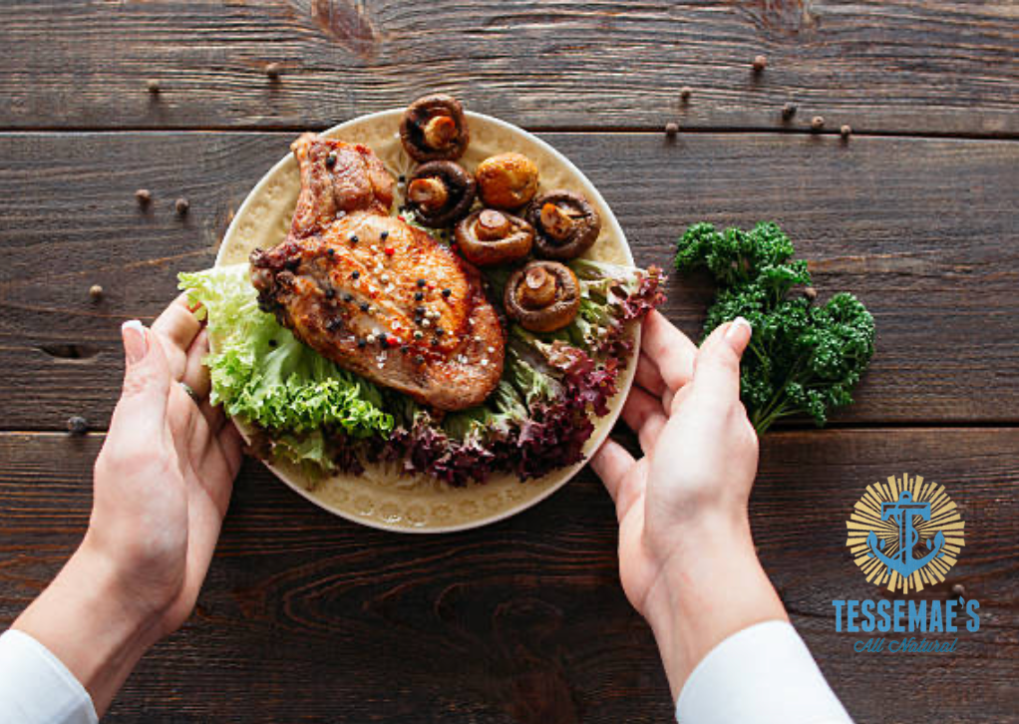
Note. Using body parts in posts, like hands, helps viewers imagine themselves as the consumer and using the watermark will keep Tessemae’s credited for the dish (Sloan & Faison, 2023b).
a Mock Caption: Freshness in Every Bite: Dive into Our Garden Salad with a Handcrafted Touch #SaladLove #HealthyEating

Identification of Example Players
Caisa-Marie Lindfors is a Sweden-native, Division 1, track and Field athlete. Attending the University of California, Berkeley, she has become known for her strong performances in discus events and has been a prominent figure in the Swedish athletic scene. She was Sweden's national champion for the discus throw in 2021 and 2023 before going on to represent Sweden in the 2023 (Track and Field Results Reporting Service, n.d.). Track and Field World Championships. Lindfors is a recent transfer to Berkeley from Florida State University. The heights of her career statistics from the Track and Field Results Reporting Service (2023) include discus: 60.90m (199-9), shot put (out-door): 16.09m (52-9.5) and shot put (in-door): 16.51m (54-2). Lindfors has also built an extensive social media presence. According to her Instagram, she currently has over 5,500 followers and her reels have gotten up to nearly 40,000 views (Lindfors, n.d.).

Content Development and Curation
Content development is unique to the specific athlete and how they may choose to promote the guided endorsement. Giving them guidelines and creative control is beneficial for them to be able to connect with their followers, but instructions on specific campaign promotions go a long way in guiding the athlete. Engagement can be boosted through multiple posts, for example “The athlete must post five times within two weeks, including three story posts and two reels” (Faison, 2023). Giving influencers hashtags to use and telling them to tag Tessemae’s page will increase sticker taps, reach, and profile visits (Mac USA Marketing, n.d.). Giving influencers an affiliate link with a tracker will offer discounts, encourage incentive-based sales, and help track the amount of attention they have received (Influencity, n.d.). Tracking and affiliate links encourage audience attention, however, social media has stringent success guidelines (see Table 3). According to Postgame (2023), a safe tracking program may look like this:

Table 3
Messaging Guidelines: Navigating Regulation
Section | Guidelines
Instagram Caption Tags and Photo Watermarks | - Always include the @tessemaes tag and watermark.  - Use the following hashtags: #IGotTheSauce, #ad, #GameOn, #flavorexplosion, #TessemaesAmbassador.
Unique Tracking URL | Apply unique tracking URLs to specific pages.
Basic Style / Content Guidelines | - Ensure that the Tessemaes brand is prominently visible in your posts.  - Do not include any competing brands or products in posts related to Tessemaes.
Technical Guidelines (Postgame, 2023) | - Verify permissions to use school logos, mascots, & marks in content.  - Ensure the product being promoted (Tessemae’s) is clearly visible in each post.  - Avoid cropping/cutting off footwear or apparel in photos featuring Tessemaes products.
Tessemae’s can gain attention from more specific audiences by strategically partnering with the right athletes. Using athlete practice and game highlights can build a passionate fan base because most athletes already disclose progress, fitness tips, and slices of their personal lives. Tessemae's can capitalize on athlete success as an easy segue for endorsing the product. By strategically partnering with the right athletes, Tessemae’s highlights the brand and offers authenticity and creativity. Further, creating behind-the-scenes content can resonate with consumers by providing a glimpse into their daily lives, competitions, and game preparation strategies. The interpersonal touch of social media can connect Tessemae’s to Lindfors' fan base by offering positive word of mouth to her fans.
Paid Post Strategy
Organic growth strategies can be formidable mediums for enhancing Tessemae’s online presence. A combination of organic and paid advertising tactics will be honed across channels to evolve and curate perfection over time (Marlow, n.d.). Organic growth strategies include posting on a schedule, enlisting employee advocacy, commissioning micro-influencers for buzz marketing, and utilizing interactive engagement with audience members. Paid growth strategies include shoppable Instagram Reels, targeted Facebook ads, and Pinterest pins (Bulatovic, 2023). Using combined organic and paid social media advertising while diversifying content and pushing brand imagery will transcend Tessemae’s to new heights of brand equity.

Sponsorship Approach
Prospect touchpoints and NIL negotiations are formal processes controlled by agencies and National Collegiate Athletic Association (NCAA) rules. Initiating personal contact via phone call, formal letter, or leadership to ensure athletes accept company offers is essential. Company communication with athletes and agents must be professional, respectful, and concise. Some athletes prefer negotiations to be handled by managers and agency personnel. Agencies have strict, NCAA-compliant rules for the athlete to maintain eligibility (Perez, 2021). Agents argue that athletes can become exploited without proper representation. Brands can also haggle the terms of the sponsorship proposal to achieve a mutually beneficial arrangement. An attorney must create a formal NIL contract specifying the partnership once negotiators come to an agreement. For propositional success, emphasize how the partnership can benefit both parties, like athletic exposure for increased brand recognition. Negotiators can establish mutual success by demonstrating respectful customer service and firm yet fair negotiations.
Caisa-Marie Lindfors offers a unique opportunity for multinational promotion possibilities. Her contractual worth is determined by the number of followers and reach, the industry standard for athletes. She is from Sweden and recently represented Sweden in the 2023 Track and Field World Championships in the discus throw (Track and Field Results Reporting Service, 2023). While Tessemae’s only ships to the United States, this sponsorship could regain traction multinationally (Tessemae’s, 2023) and expand revenue and market share long-term.

Monitoring and Analytics
Tessemae’s will use analytics tools to measure KPIs for weekly distillation. Google Analytics, social media analytics, and various APIs will monitor KPIs and link-building growth for overall progression. Some of the more notable KPIs are likes, shares, and follower growth rate, but the M&E plan under Control and Implementation details the rest of the KPIs. The Bigeye team will tailor the plan to perfection in weekly refining meetings. Then, the finalized report will require an endorsement from Todd Fletcher, VP of Marketing (2023), and final approval from Brian C. Vetter, CMO (2023). The IMC program will strengthen as the team progresses through the clarification and curation process.

Community Engagement and Interaction
Creating a strong community engagement strategy for NIL deals involves using the athlete's social media presence to cultivate a vibrant and connected audience. By making authentic and relatable content, such as behind-the-scenes peeks, and day-to-day training regimens, the chosen athlete can help Tessemae’s create a stronger connection with their followers. Creating interactive content is another way to enhance engagement. Ambassadors can increase engagement by using features on Instagram, like Questions and Answers (Q&A) posts or polls.
Engaging directly with followers is a great way for the consumer to feel connected to the product. The ambassador could also demonstrate recipes using the product to give examples of how to use it in healthy, trendy ways. Consistency is also an imperative way to keep engagement high. Keeping a captivating and organic presence with consumers will increase revenue throughout the company. By casually and nonchalantly incorporating Tesseamae’s into Lindfors content using product placement, a message of authenticity is realized for consumers.
Lindfors and Tessemae’s can work together by utilizing her tailored, dedicated following, while also seeking mass audiences with reels. Reels are one of the best ways to reach beyond the influencer’s immediately following and into the cold market (Newberry, 2022). An ambassador's reel engagement will be significantly higher than regular algorithmically limited posts. Reels can be discovered on Instagram's Explore Page where keywords distribute the advertisements to targeted mass cold markets. By leveraging the dynamic reach of Instagram Reels, Lindfors and Tessemae's collaboration has the potential to not only engage her dedicated followers but to significantly expand both player’s audiences, tapping into new markets and enhancing brand visibility.

Integration with Overall Marketing Strategy
Using social media through NIL deals, Tessemae’s will boost its overall engagement and sales revenue. By aligning the strategy with the ambassador’s beliefs and lifestyle, it seemingly integrates the sponsored content without feeling forced towards the consumer. Their fan-base is more likely to want to support brands of idols they follow. An athlete’s social presence has been pivotal in the past few years to integrate companies. Without compromising integrity, a mix of engaging content can serve as promoted sponsorships. It also shows that companies are invested in young adults' futures.

Tactic Summary
In conclusion, these social media channels will be tailored to the target market segment and Sophia Greenwell persona using an interpersonal approach within paid and organic strategies. The Game On: Clean Meets Cuisine campaign represents Tessemae's comprehensive strategy to amplify its brand presence across Facebook, Instagram, and Pinterest, utilizing micro-influencer partnerships, product innovation, social media funneling, and targeted engagement tactics, like hashtag promotions, to connect with audiences and drive growth in the digital landscape. The Vetter family and Tessemae’s stands to gain a sizable equity from fostering a personalized, human connection with the TAM through social media.

Budget
Tessemae’s marketing budget focuses on enhancing its market presence with new product development, content creation, influencer partnerships, and digital marketing strategies. Sloan and Faison (2023) designed Tessemae's budget with contingencies for market fluctuations and a dynamic approach to expenditure-based performance metrics. This detailed financial plan aims to boost Tessemae's market position and drive growth, as outlined in the comprehensive budget table (see Table 4). Sloan and Faison (2023) also devised Tessemae's marketing budget to amplify its market footprint, incorporate product development, and boost digital marketing while considering contingencies for performance-based spending.
The new product line will be designed and implemented on a low starting budget, pending returns. By setting aside $10,000 in manufacturing funds, thousands of two-ounce glass, circa 2014-inspired, wax-sealed hot sauce bottles should be readily available for digital markets by the second quarter. If Tessemae’s opts for the classic bottle design, sales will come at massive profit margins for minimal design costs. This strategic approach ensures Tessemae’s can introduce mini hot sauce bottles to the market with financial prudence while allowing economies of scale based on reception and sales performance.
Next, content creation and management, subtotaling $24,000, will be exploited for engaging, trendy, and meaningful content. Budgetary focuses on content creation and contrives three cornerstones: graphic design and multimedia for $12,000, copywriting and content production for $10,000, and social media management tools like Sprout Social (Aboulhosn, 2020) for $4,000. This strategic allocation accentuates Tessemae’s commitment to a resonant online presence while ensuring each semblance within the content ecosystem primes for maximum audience impact.
Informal logical fallacies will persuade the target market segment into the purchase funnel. The company will spend $20,000 on NIL partnerships to appeal to wealth, celebrities, and popularity while building brand loyalty and fostering consumer sentiment (Bennett, 2013-Thompson, n.d.-Trovato, 2023). Influencer appeal is a new celebrity marketing and ad placement tactic commonly appropriated through micro-influencer partnerships ($15,000) and product giveaways via sweepstakes and contests ($5,000). By judiciously leveraging the influence and personal touch of micro-influencers, Tessemae’s widens its reach and forges authentic, long-lasting connections.
The backbone of the strategy is the flavor funnel, which will be created and maintained through consulting, software, and API integration. Funnel strategy consulting ($7,000), social media analytics software ($6,000), and API integration ($3,000) are investments with a return on marketing investment (ROMI), outperforming the breakeven point of the $16,000 allocation. The Lifetime Value-Customer Acquisition Cost (LTV-CAC) ratio has five to 10 times revenue, 2.5 to five times sales profit, and a 50% gross margin (Kazankov, 2023). Investing in this sophisticated infrastructure situates Tessemae’s as a digital vanguard while constructing a data-centric approach to markedly upraise the profitability of customer outreach.
To optimize the online purchase experience, Tessemae's will invest in e-commerce platforms and POS systems, amounting to a total annual cost of $7,400 for improving the sales process, customer experience, and overall conversion efficacy. The e-commerce platforms (POS systems) will cost $2,400 annually, with customization and setup costs of $5,000. Linking a POS to the landing page will shorten the purchase journey and lower bounce rates. This strategic investment will streamline sales processes, enhance customer experience, boost conversion rates, and catalyze value capture. Tessemae's investment in e-commerce and POS systems will aggrandize customer experiences and sales efficiency, reflecting a strategic commitment to optimizing online transactions.
Within the social media funneling method, website optimization is imperative because the landing page tops the flavor funnel. Every site visit concludes with either a bounce or a purchase. Website UX/UI design improvements of $8,000 and conversion rate optimizations of $6,000 will incur a subtotal of $14,000 for the brand. A digital point-of-purchase display must be powerfully constructed and equipped with a vigorous call to action. By punctiliously refining the user experience, Tessemae's asserts to significantly diminish bounce rates by elevating the conversion probability of visits into valuable sales, assuring every new touchpoint is as compelling as the first.
To enhance Tessemae's marketing initiatives, the Bigeye Agency offers an array of specialized services at an annual rate of $103,665 and asserts bespoken, expert handling of the promotional campaign. It proposes a fee-based monthly income of $8,638.75 for the acquisition of its marketing services. This investment into Bigeye's comprehensive marketing expertise promises a varied approach to Tessemae's promotional efforts and certifies a committed role specialist maneuvers every campaign feature. Investing in Bigeye provides Tessemae's with an adroitly liaised marketing approach, expertly managed by a suite of pros.
Tessemae's mini hot sauce budget focuses on developing appealing packaging, sourcing quality materials, and ensuring efficient distribution to meet consumer expectations and brand pathos. The Tessemae's mini hot sauce budget includes $9,000 in packaging design, manufacturing, and distribution costs. A sizable portion of the funds will also be used for purchasing materials, focusing on high-quality glass bottles and aesthetically pleasing labels. Additionally, the budget encompasses the manufacturing and distribution costs, ensuring the mini hot sauce bottles efficiently reach the market, aligning with the distribution strategy and consumer accessibility goals.

Table 4
Budget: Tessemae's Social Media Growth Campaign (2023-2024)
Category | Details | Annual Cost
Social Media Advertising |  | $28,000
Instagram Sponsored Posts | Reels, stories, collabs, & ads | $15,000
Facebook Ads | Shorts, stories, collabs, & ads | $10,000
Pinterest Sponsored Content | Articles, Content, Page Growth, & Affiliate Links | $3,000
New Package Design, Supplies, & Manufacturing |  | $10,000
Content Creation & Management |  | $22,000
Graphic Design & Multimedia | e.g., Logos, taglines, color schemes, & landing page | $9,000
Copywriting & Content Production | Instagram Reels, Pinterest & Facebook posts, website copy, & PR | $9,000
Social Media Management Tools | Sprout Social, Hootsuite, HubSpot, Brandwatch, etc. | $4,000
Influencer Partnerships |  | $20,000
Micro-Influencer Collaborations | Grin, Creator.co, Upfluence, Klear, etc. (Geyser, 2023) | $15,000
Product Giveaways | Sweepstakes & contests | $5,000
Social Media Funnel Development |  | $16,000
Funnel Strategy Consulting | Amy Higgins (LinkedIn, n.d.), Shanna Bell (n.d.) | $7,000
Apps for Social Media Analytics | e.g., Sprout Social, Google Analytics, Rival IQ, etc. (West, 2023) | $6,000
API Integration for Data Scraping | i.e., Pinterest APIs, Instagram APIs, Google Analytics v1, (Rapid API, n.d.) | $3,000
E-Commerce Platform (POS System) |  | $7,400
Annual Subscription | e.g., Shopify, Lightspeed, or Toast | $2,400
Customization and Setup | Accept all payment types/maintenance costs & implementation costs. | $5,000
Website Optimization |  | $13,000
Website UX/UI Design Improvements | Shorten touchpoints and ease the prospect’s decision-making journey. | $7,000
Conversion Rate Optimization | Landing page optimization, digital point-of-purchase, & POS access | $6,000
Agency Fee (Bigeye Agency) | $8,638.75 per month for marketing team labor—all included fees for one year. | $103,665
Contingency Funds | 5% of total budget | $12,945
Production Costs | 10% of total budget | $25,890
 | Total Estimated IMC Budget | $258,900
Note. The actual costs may vary based on the specific service providers chosen and market conditions during the campaign. Researchers recommend regular reviews and budget adjustments to ensure spending efficacy regarding media and advertising objectives (Sloan & Faison, 2023).

Control and Implementation
Tessemae's is preparing to implement a Monitoring, Evaluation (M&E), and Control plan that is as robust as it is insightful, leveraging the six-step framework developed by Compass (2012) to foster continuous project enhancement and informed decision-making. Tessemae's M&E plan entails the implementation of the program, adherence to established goals and objectives, application of the logic model, monitoring of KPIs, employment of tables for data sources, development of a comprehensive information table, clarification of roles and responsibilities, continuous reporting, and strategic application of the dissemination plan. This M&E framework will create a feedback loop of customer insights ensuring constant growth and development.
Building on this established foundation, Tessemae's veraciously designs the subsequent steps of its M&E plan turning brand-centric promotional efforts into measurable outcomes and strategic growth. Introducing the promotional plan is the first step in Tessemae's M&E journey. The campaign is crucial for enhancing brand recognition and emphasizing Tessemae's commitment to healthy and natural ingredients (Kingdom Branding, n.d.). By aligning promotional activities with Tessemae's core values, the campaign aims to strengthen the brand's market position as a leader in health-conscious food choices while expanding its customer base.
Transitioning from foundational planning to tactical execution shifts the focus to integrating the specific marketing, communication, advertising, and media objectives with the broader IMC program while ensuring weekly M&E goal assessments align with overarching growth ambitions. The following communication objectives guide weekly M&E assessments:
- The advertising specialist will measure the reach of the IMC program across platforms and weekly engagement for brand awareness and audience interest.
  - Likes, shares, and comments will measure reach.
- The advertising specialist will target audience actions that lead to conversions and other desired promotional outcomes (Simborg, 2022).
  - Google Analytics will determine weekly statistical changes.
- The advertising specialist will address problem areas in the campaign (Silva, 2022).
  - Google Analytics will decipher weekly loss metrics, such as bounce rates, unfollows, blocks, et cetera, as well as where in the purchase funnel they happen the most.
- During week one, the advertising specialist will calculate and compare the promotional campaign's cost-effectiveness (Corporate Financial Institute, n.d.).
  - CAC with industry averages and pre-campaign data will determine cost-effectiveness.
- The advertising specialist will perform quarterly evaluations of the campaign’s impact on brand image (Barney, n.d.).
  - Sentiment analyses from customer surveys and will measure campaign impact.
- The social media manager will monitor customer feedback channels and measure the campaign effectiveness of weekly customer service responses.
  - APIs and apps, like Brandwatch (n.d.), will measure customer feedback and campaign effectiveness, aiming for high satisfaction and resolution rates.
- The advertising specialist will calculate and monitor the weekly ROMI (Fenske, 2020).
  - The advertising specialist calculates ROMI by comparing increased revenue with campaign costs to determine the ROI.
- To ensure Tessemae's sustainability claims align with the brand values and to avoid false nutritional claims, the public relations specialist will perform weekly content authenticity reports (Fair, 2023).
  - Micro-influencers will be monitored for publicity and false claims control, packaging labels will be monitored for quality assurance, and an endeavor against counterfeit products will be established with the public.
- The advertising specialist will monitor sales per region and increase visibility (Lyons, 2022).
  - Sales will be monitored weekly using Google My Business, Google Analytics, and Salesforce (Salesforce, 2022).
- The advertising specialist will determine whether the campaign was successful.
  - By making quarterly comparisons of baseline data and post-campaign data to determine whether market share and sales have increased.
These goals will serve as benchmarks to determine campaign success and identify areas for improvement, ensuring Tessemae’s promotional efforts effectively contribute to company growth and equity gains.
Next, KPIs measure headway in achieving its objectives. Some of the KPIs for this campaign are the weekly changes in the follower growth metric, likes, engagement, posting frequency, traffic conversions, web visitors by channel source, social sentiment, mentions, customer feedback, private message requests, link-building instances, and social shares (Klipfolio, n.d.). The primary KPIs measure the Total Addressable Market (TAM), Serviceable Available Market (SAM), and SOM (Chi, 2023) (see Figure 16). The social media manager will monitor these KPIs. This comprehensive suite of KPIs will earnestly track progress for actionable insights, steering the promotional strategy toward its targeted milestones.

Figure 16
Primary KPIs: TAM, SOM, and SAM
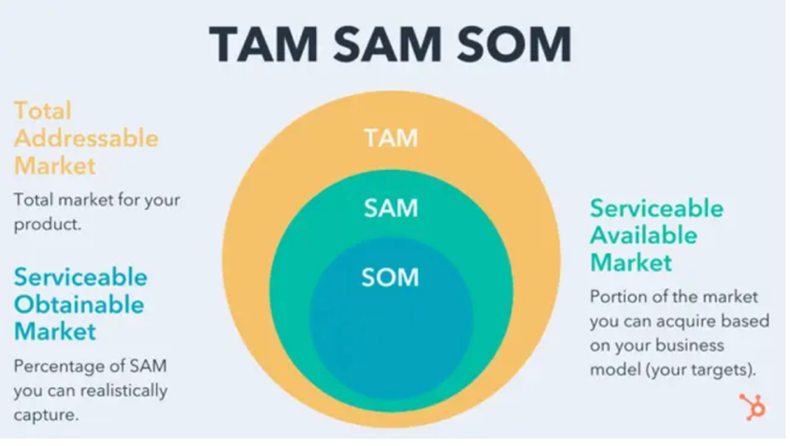
Note. This artifact shows the layers within the target market segment, all of which require various levels of effort for obtainability. The entire circle represents the target market segment, while the SOM is Sophia Greenwell.
Tables with data sources will also be collected weekly by the communications manager. The advertising specialist will download a comprehensive table outlining social media analytics, sales figures, and conversions from Google Analytics every Sunday by the end of the day (for example) before sending it to the communications manager for the first review. The analytics report will then be emailed to the rest of the team pending weekly Microsoft Teams eval meetings where the marketing manager, communications manager, public relations specialist, social media manager, M&E specialist, and advertising specialist create the weekly planning proposal. Todd Fletcher will receive this proposal and must approve the weekly plans before the marketing team can execute them. This process outlines a systemic approach. The advertising specialist compiles vital data, facilitating collaborative review and planning from Bigeye’s marketing team, approved by Fletcher, warranting strategic alignment and overall execution efficiency.
Collaboration between Tessemae's and Bigeye’s specialized team will orchestrate a multifaceted approach to achieving marketing and communication objectives. Six attendants from the Bigeye Agency (Bigeye Agency, n.d.) will liaise with Tessemae’s on the M&E plan. They are a social media manager, public relations specialist, marketing manager, communications manager, advertising specialist, and M&E specialist (Probably Good, n.d.) (see Table 4). The Bigeye team will interface the feedback loop with Tessemae’s VP of Marketing, Todd Fletcher. Together, this six-member external marketing team working under Fletcher will tackle goals.

Table 4
Bigeye & Tessemae's IMC Marketing Team Structure
Team Member | Role/Responsibility | Reports to
Social Media Manager | Oversees social media planning, execution, & maintenance, & manages a content creator | Tessemae’s VP of Marketing
Public Relations Specialist | Monitors public relations & publicity implications associated with the IMC plan | Tessemae’s VP of Marketing
Marketing Manager | Leads marketing plan design, execution, & maintenance | Tessemae’s VP of Marketing
M&E Specialist | Oversees M&E process | Tessemae’s VP of Marketing
Communications Manager | Oversees the communication plan within the greater IMC program | Tessemae’s VP of Marketing
Advertising Specialist | Controls all advertisements, analytics, & data scraping | Tessemae’s VP of Marketing
Tessemae’s VP of Marketing | Oversees the Bigeye team, & monitors progress through weekly planning meetings & monthly evaluations | Tessemae’s Senior Management
The marketing team will distribute the M&E findings through a front-back delivery model, keeping internal teams and external stakeholders fully apprised (van Vulpen & Veldsman, n.d.). Internally, the team will systematically integrate discoveries into strategic reviews and decision-making models, facilitated by regular summits and debriefs. Tessemae's will use a range of formats, such as detailed reports, dashboards, and presentations, to ensure clarity and to provide actionable insights. Externally, key stakeholders, such as investors, will be engaged through quarterly business reviews where perspicuity will foster trust. External dissemination will utilize formal reports and executive summaries to communicate campaign progress and impact (Sarver & McNett, 2019). This comprehensive approach ensures effective and transparent communication of Tessemae's marketing insights across all relevant channels.
Following this delineation, the marketing team will monitor, evaluate, and control Tessemae's promotional plan to amend campaign performance. Communication and M&E objectives will be met and maintained within one year, bringing Tessemae's unfathomable brand equity and market share. At the annual cycle conclusion, the marketing team will evaluate tactics and draft a new plan. With this approach, Tessemae's exceeds M&E objectives, gaining market influence and establishing a reputation as a clean food leader.

Conclusion
To finalize, Sloan and Faison (2023) have used original research, expert input, and AI to target a market segment of trend-dieters and a buyer persona named "Sophia Greenwell," meaning sophistication, green-eating choices, and wellness. The Game On: Clean Meets Cuisine campaign represents Tessemae's comprehensive strategy to amplify its brand presence across Facebook, Instagram, and Pinterest. This campaign will utilize micro-influencer partnerships, product innovation, social media funneling, and targeted engagement, like hashtag promotions, to connect with audiences and drive growth in the digital landscape. By capturing NIL partnerships with female athletes, creating a social media funnel, innovating new value for the customer with purse-picantes, and employing the #IGotTheSauce hashtag, Tessemae’s pivots itself toward successful market coverage.
With the help of strong female athletes, Tessemae’s can push into segment adjacencies within the fitness community. Faison (2023) chose Caisa-Marie Lindfors as the ideal brand ambassador, and this partnership will mark the beginning of an NIL effort, targeting trend-dieters and penetrating college sports. Her dual nation ties offer opportunities for globalization into the EU, presenting Tessemae’s with the chance to capitalize on A/B and multivariate testing for future globalization efforts. Together, the two entities will attain mutual benefits including equity gains and compounding social status.
Tessemae’s will also create a premeditated customer journey to boost conversions with a social media funneling system. Termed the “flavor funnel,” this social media funnel will favor Facebook, where viable audiences have yet to be captured, while funneling prospects toward a POS on Tessemae’s landing page for a succinct, quick, routinized purchase decision with minimal bounce or dissonance (Sloan & Faison, 2023). By simplifying the pipeline and clearing bottlenecks, Tessemae’s will increase brand awareness by 28.57%, stabilize follower growth rate at five percent, and secure a steady five percent conversion rate YOY. With the flavor funnel, Tessemae’s stands as an unstoppable digital nomad within the organic salad dressing industry.
The four customer value imperatives have also been considered, particularly innovating new value for the customer. Tessemae’s has experienced augmented growth during times of “big i" innovation. In lieu of that, Sloan (2023) has recommended cultural innovations that strongly appeal to Sophia Greenwell, the buyer persona, by making every meal a statement of style, innovation, and intrigue for female trend-dieters. Purse-stable picantes are an eclectic array of shelf-stable, organic, flavor-forward hot sauces sustainably packaged for travel. The ladies who love hot sauce on everything will positively respond to this appeal to social good, zeitgeist, and cool hunting.
Speaking of cool hunting, while pushing the new hot sauce line, the #IGotTheSauce hashtag will be a viral social media trend encouraging positive buzz marketing. According to Sloan and Faison (2023), this diversifiable hashtag also appeals to the female athletes who will represent Tessemae’s as brand ambassadors, creating an invaluable appeal to authority for trend-dieters, cool-hunters, and foodies. By manipulating SMO and SEO keywords, Tessemae’s will become a favorable entity within social media algorithms, stimulating effortless growth.
Tessemae’s is on the fast track to successful market coverage with strategic implementations, like NIL partnerships with female college athletes, social media funneling, innovating new value for the customer with purse-picantes, and employing the #IGotTheSauce hashtag. The Game On: Clean Meets Cuisine campaign represents Tessemae's comprehensive strategy to amplify its brand presence across Facebook, Instagram, and Pinterest. This campaign will utilize micro-influencer partnerships, product innovation, social media funneling, and targeted engagement, like hashtag promotions, to connect with audiences and drive growth in the digital landscape. These strategies will pivot Tessemae’s toward digital marketing triumph, with projections of nearly 29% brand awareness gains, a steady five percent conversion rate, and a stabilized five percent follower growth rate. With the current restructuring, this promotion can act as a secret weapon for the company. Embrace the taste of transformation now.

References
Aboulhosn, S. (2020, February 19). How to build a social media marketing funnel that converts. Sprout Social. https://sproutsocial.com/insights/social-media-marketing-funnel/.
Adidas instructions (main). POSTGAME APP. (n.d.). https://www.home.pstgm.com/adidascampaign1
Amick, B. (2018, May 18). One-third of consumers follow a specific diet. Baking Business. https://www.bakingbusiness.com/articles/46033-one-third-of-consumers-follow-a-specific-diet.
Annie’s. (n.d.). Annie’s. General Mills. https://www.generalmills.com/food-we-make/brands/annies.
Andrea Suozzo, A. G. (2013, May 9). Newman's Own Foundation - nonprofit explorer. ProPublica. https://projects.propublica.org/nonprofits/organizations/61606588.
Anonymous. (2022, November 29). Politics in the San Francisco Bay Area. Wikipedia. Retrieved November 2, 2023, from https://tinyurl.com/rrrfgt.
Arain, M., Haque, M., Johal, L., Mathur, P., Nel, W., Rais, A., Sandhu, R., & Sharma, S. (2013, April 3). Maturation of the adolescent brain. PubMed Central. National Library of Medicine. National Center for Biotechnology Information. Neuropsychiatric Disease and Treatment. (Volume 9, PP. 449-461). DOI: 10.2147/NDT.S39776.
Beer, J.S., Oliver, J.P., Scabini, D., & Knight, R.T. (2006, June 18). Orbitofrontal cortex and social behavior: integrating self-monitoring and emotion-cognition interactions. Journal of Cognitive Neuroscience. National Library of Medicine. National Center for Biotechnology Information. PubMed. DOI: 10.1162/jocn.2006.18.6.871.
Belch, G. E., & Belch, M. A. (2021). Perspectives on consumer behavior. Advertising and promotion: an integrated marketing communications perspective (12th ed., pp. 115-157). McGraw-Hill Education.
Bennett, B. (2013, November 22). Argument to the purse. Logically Fallacious. Reason: Books I & II. First Ed. Archieboy Holdings. https://www.logicallyfallacious.com/logicalfallacies/Argument-to-the-Purse.
Bigeye Agency. (n.d.). Bigeye is a strategy-led, full-service, creative agency growing consumer brands globally. https://tinyurl.com/ijjjioo.
Brandwatch. (n.d.). AI consumer insights for audience analysis. https://tinyurl.com/iojoijiio.
Bulatovic, J. (2023, November 01). The ultimate guide to paid social advertising. Hunch. Meta. Hunch Insights Inc. https://www.hunchads.com/blog/the-ultimate-guide-to-paid-social-advertising.
Barney, N. (n.d.). Sentiment analysis (opinion mining). TechTarget. https://www.techtarget.com/searchbusinessanalytics/definition/opinion-mining-sentiment-mining.
Caisa-Marie Lindfors – Track and Field Results & Statistics. TFRRS. (n.d.). https://www.tfrrs.org/athletes/7730608/Florida_State/Caisa-Marie_Lindfors.html
California Department of Food and Agriculture. (2022). California Agricultural Organics Report (2021-2022). State Organic Program. https://www.cdfa.ca.gov/Statistics/PDFs/2022_Organics_Publication.pdf.
Cinelli, M., De Francisci Morales, G., Galeazzi, A., & Starnini, M. (2021, February 23). The echo chamber effect on social media. Proceedings of National Academy of Science (PNAS). Arild Underdal. University of Oslo, Norway. https://doi.org/10.1073/pnas.2023301118.
Chi, C. (2023, June 1) TAM SAM SOM: What do they mean & how do you calculate them? Hubspot. (2023). https://blog.hubspot.com/marketing/tam-sam-som.
Clare. (2023, August 17). Salad dressing market size & share analysis—growth trends & forecasts (2023-2028). Reportlinker. Globe News Wire. Notified. https://www.globenewswire.com/news-release/2023/08/17/2727538/0/en/Salad-Dressing-Market-Size-Share-Analysis-Growth-Trends-Forecasts-2023-2028.html.
Cleveland Kitchen. (2022, June 13). Cleveland Kitchen closes $19M series A to accelerate its continued growth as a category leading fermented food brand. PR Newswire. https://www.prnewswire.com/news-releases/cleveland-kitchen-closes-19m-series-a-to-accelerate-its-continued-growth-as-a-category-leading-fermented-food-brand-301566525.html,
Colabstr. (2023, March 22). Are Instagram ads worth it in 2023? Complete guide for getting the most out of Instagram ads. https://tinyurl.com/hhhhhn
Compass. (n.d.). How to develop a monitoring and evaluation plan. https://tinyurl.com/8787878qq
Corporate Finance Institute. (n.d.). Customer Acquisition Cost (CAC). https://tinyurl.com/uuiuiu
Corporate Financial Institute Team. (n.d.). Effective annual interest rate: Interest rate adjusted for compounding over a given period. Corporate Financial Insititute (CFI). Macabacus. (2015-2023) CFI Education Incorporated. https://tinyurl.com/zzzzzcht
Craft. (n.d.). Tessemae's competitors and similar companies. https://craft.co/tessemae/competitors.
Crunchbase. (n.d.). Primal Kitchen. https://www.crunchbase.com/organization/primal-kitchen.
Dash This. (n.d.). Cost per thousand (CPM). https://tinyurl.com/asaasasaqq
Dashly Blog. (2020, March 11). The ROMI formula: How to calculate it? Real case. https://tinyurl.com/dfdfdfdddd
Day, G., Moorman, C. (2011). Strategy from the outside in.
De Borja, C., Holtzman, B., McCall, L. M., Carson, T. L., Moretti, L. J., Farnsworth, N., & Ackerman, K. E. (2021, April 17). Specific dietary practices in female athletes and their association with positive screening ordered for disordered eating. Journal of Eating Disorders. Article 50. Biomed Central. https://jeatdisord.biomedcentral.com/articles/10.1186/s40337-021-00407-7#:~:text=Dietary%20practices%20among%20female%20athletes&text=Of%20the%20134%20athletes%20who,%2C%20and%20pescatarian%20(4.5%25).
de Guzman, D. (2022, June 15). Campy Maximalism, please: how the trash-glam aesthetic is making Bay Area restaurants fun again. Eater SF. https://www.eater.com/san-francisco.
Deadhoe9. (2021). Do you carry hot sauce in your purse, bag, etc. When you leave the house? R/spicy. Reddit. Retrieved November 11, 2023, from https://www.reddit.com/r/spicy/comments/qi3v94/do_you_carry_hot_sauce_with_you_in_your_purse_bag/?rdt=41119.
Dean, B. (2023, August 23). How many people use Instagram? 95+ user statistics (2023). Backlinko. https://tinyurl.com/jjjkkllklj.
DeeFeeCee. (2023, September 21). Orbitofrontal cortex. Wikipedia. MediaWiki. Wikipedia Foundation (2023). Retrieved November 11, 2023, from https://tinyurl.com/kjdjsdjsidj.
Dingman, M. (n.d.) Orbitofrontal cortex: definition. Neuroscientifically Challenged. https://neuroscientificallychallenged.com/glossary/orbitofrontal-cortex.
Drumheller, J. (2015, October 2). Tessemae’s logo and label design [Image]. Behance. https://www.behance.net/gallery/29953353/Tessemaes-All-Natural-Logo-Label-Design.
Dodier, S. (2020, May 26). Feminism and diet culture. Going beyond the food method. from https://www.stephaniedodier.com/feminism-and-diet-culture/.
Dunn, P.K. (2023). Tubular summaries. Scientific Research and Methodology: An Introduction to Quantitative Research and Statistics 12(4). https://tinyurl.com/kofdfdfd.
Emergency Communication Preparedness Implementation Kit. (n.d.). Identify a set of SMART communication objectives. Unit 6: Communication Objectives and Indicators. SBCC For Emergency Implementation Kit. https://sbccimplementationkits.org/sbcc-in-emergencies/identify-a-set-of-smart-communication-objectives/.
Enyatv. (2009). Enya-Only Time (Official 4k Music Video) [Video]. Enya. YouTube. https://www.youtube.com/watch?v=7wfYIMyS_dI.
Fair, L. (2023, February 17). A warning to marketers about testi-phony-als, including ads Falsely claiming a “Shark Tank” connection. Federal Trade Commission. https://www.ftc.gov/business-guidance/blog/2023/02/warning-marketers-about-testi-phony-als-including-ads-falsely-claiming-shark-tank-connection.
Fallacy Files. (n.d.) Appeal to celebrity. https://www.fallacyfiles.org/apcelebs.html.
Finck, B. (2021, November 25). 5 things companies should know about NIL. Dreamfield Sports. https://www.dreamfield.co/resources/what-companies-should-know-about-nil.
Fletcher, T. (2023) Managing partner six60 partners. LinkedIn. Retrieved November 14, 2023, from https://www.linkedin.com/in/tfletch2007/.
Frequently asked questions (faqs). Tessemae’s. (n.d.). https://www.tessemaes.com/pages/frequently-asked-questions
Friedman, H. (2023, October 20). Crucial strategies for effective marketing budget development. Improvado. https://improvado.io/blog/crafting-marketing-budget-guide.
Fuego Spice Co. (n.d.). Zana organic habanero hot sauce. (2019). https://fuegospice.com/products/zana-organic-habanero-hot-sauce.
Future Market Insights (FMI). (n.d.). Organic salad dressing market. https://www.futuremarketinsights.com/reports/salad-dressings-and-mayonnaise-market.
Geyser, W. (2023, October 31). 21 U.S. based influencer marketing platforms that influencers and brands around the world should know. Influencer Marketing Hub. https://influencermarketinghub.com/influencer-marketing-platforms-usa/.
Goldman, A. (1982). Short product life cycles: implications for the marketing activities of small high-technology companies. R&D Management, 12(3). DOI Foundation. https://doi.org/10.1111/j.1467-9310.1982.tb00487.x.
Gorynski, M. (2023, September 1). Millennials vs. Gen Z: differences in customer service expectations. Zendesk Blog. Zendesk. https://www.zendesk.com/blog/millennials-vs-gen-z-differences-customer-service-expectations/.
Green, A. (2021, March 7). How local businesses, college athletes are taking advantage of the Nil Era. The Reynolds Center. https://businessjournalism.org/2021/10/how-local-businesses-college-athletes-are-taking-advantage-of-the-nil-era/
Grey, C. (n.d.) What is SEO and SMO digital marketing? SEMRush. https://charleygrey.com/marketing/what-is-seo-and-smo-in-digital-marketing.
Grozanik, R. (n.d.). Romancing the scone: Social media and the sexualization of food. Ruggles Media. Northeastern University. Surgey Klimkin, Pixabay. https://web.northeastern.edu/rugglesmedia/2016/10/04/romancing-the-scone-social-media-and-the-sexualization-of-food/.
Guidetti, M., Carraro, L., & Cavazza, N. (2022). Dining with liberals and conservatives: the social underpinnings of food neophobia. PLoS ONE, 17(1), PubMed. National Institutes of Health (NIH). National Library of Medicine. National Center for Biotechnology Information. e0262676. https://doi.org/10.1371/journal.pone.0262676.
Hansmann, R., Baur, I., Binder, C.R., Increasing organic food consumption: an integrating model of drivers and barriers. Journal of Cleaner Production (Volume 275). https://doi.org/10.1016/j.jclepro.2020.123058.
Haumann, B. (2013, April 4). Eight in ten U.S. parents report they purchase organic products: trust in the U.S.D.A. organic seal reaches an all-time high among organic buyers. Organic Trade Association. https://ota.com/news/press-releases/17124.
Henderson, J. M. (2013, August 31). Meet the multi-million-dollar condiment company run by Millennials. Forbes. https://www.forbes.com/sites/jmaureenhenderson/2013/08/31/meet-the-multi-million-dollar-condiment-company-run-by-millennials/?sh=105242fb2ae7.
Henricks, M. (2019, October 08). What is PR’s role in the fight against disinformation? Provokemedia. Holmes Report LLC. https://www.provokemedia.com/latest/article/what-is-pr-s-role-in-combatting-disinformation.
Herd Digital. (2023, March 8). Facebook statistics you must know in 2023. Digital Marketing News. https://herd.digital/blog/facebook-statistics-2022/#:~:text=2.9%25%20of%20people%20between%20the,of%2035%2D44%20use%20Facebook.
Higgins, A. (n.d.) Data-obsessed, Strategic Integrated Content Marketing Leader. Alumni of Twilio and Salesforce. LinkedIn. https://www.linkedin.com/in/amywhiggins/.
Hoffman D., Kopalle, P., and Novak, T. (2009). The "right" consumers for the best concepts: a methodology for identifying emergent consumers for new product development. NA - Advances in Consumer Research (Volume 36, PP. 571-572). McGill & Shavitt. Association for Consumer Research. https://tinyurl.com/dfdfdfdsd.
Hoover, M., Haytko, D. (2007, July 9). A conversation with ... Diana Haytko. Springfield Business Journal (SBJ). https://sbj.net/stories/a-conversation-with-diana-haytko,32184?
Hughes, B. (2017, August 1). 9 mini condiment bottles, jars, and tins that will save you from lunchtime emergencies. Epicurious. Food Innovation Group. Condé Nast. https://www.epicurious.com/expert-advice/9-mini-condiment-bottles-jars-and-tins-for-lunchtime-emergencies-article.
Influenster. (n.d.) Your next favorite thing is here [Landing Page]. https://www.influenster.com.
instagram. (n.d.). https://www.instagram.com/caisamarielindfors/
Jennifer. (2022, June 03). 12 Tips to reduce bounce rate and boost your conversions. Conversion Rate Optimization Blog. Optinmonster. https://optinmonster.com/12-tips-to-reduce-bounce-rate-and-boost-your-conversions/.
Josephson, A. (2022, December 2). The average salary of a Millennial. Smart Asset. https://smartasset.com/retirement/the-average-salary-of-a-millennial.
Karatas, G. (2023, October 6). 7 web scraping best practices you must be aware of in ’23. AI Multiple. https://research.aimultiple.com/web-scraping-best-practices/.
Kazankov, V. (n.d.) How to calculate ROMI (Return on Marketing Investment). MarketingforIT. https://marketingforit.com/strategy/return-on-marketing-investment#:~:text=on%20Marketing%20Investment-,ROMI%20is%20one%20of%20the%20key%20metrics%20for%20investors,on%20a%20gross%20profit%20basis.
Kean-Sharp, K. (n.d.) “I got hot sauce in my bag swag”: The diasporic roots of hot sauce in black American culinary culture. Oxford Symposium. https://www.oxfordsymposium.org.uk/wp-content/uploads/2020/06/Sharp.pdf.
Kelly, M. (n.d.). New research: Do pictures of people increase Facebook engagement? Convince & Convert. https://www.convinceandconvert.com/social-media/new-research-do-pictures-of-people-increase-facebook-engagement/.
Kelly, R., Lowrey, K. (2015, June 11). Whole Foods Market introduces 365 by Whole Foods Market. Businesswire. Berkshire Hathaway. https://www.businesswire.com/news/home/20150611005202/en/Whole-Foods-Market®-Introduces-365-by-Whole-Foods-Market™.
Kemp, S. (2023). Pinterest users, stats, data, trends, and more. Datareportal. Global digital insights. DataReportal. https://datareportal.com/essential-pinterest-stats#:~:text=Based%20on%20Pinterest%27s%20advertising%20audience%20data*%20for%20April%202023%3A&text=79.5%25%20of%20Pinterest%27s%20global%20users,users%20are%20of%20%27unspecified%27%20gender.
Kingdom Branding. (n.d.). Origin as your compass: Defining your ethos. https://tinyurl.com/fdeefedsfdfd.
Keytomyheart. Ask and you shall receive. Instagram. #SaucePorn. https://www.instagram.com/p/Cmes1hiKqwg/.
Kitunen, A., Rundle-Thiele, S., & Carins, J. (2019). Segmenting young adult university student's eating behaviour: A theory-informed approach. Nutrients, 11(11), 2793. PubMed Central (PMC).https://doi.org/10.3390/nu11112793.
Klipfolio. (n.d.). Social media KPIs & metrics. https://www.klipfolio.com/resources/kpi-examples/social-media.
Lavin, M. (1996). Ethnic/racial segmentation: insights from theory and practice. Journal of Retailing and Consumer Services (Volume 3, Issue 2. Pages 99-105). https://doi.org/10.1016/0969-6989(95)00058-5.
Lawrence, I. (2022, July 31). The brothers behind Cleveland Kitchen grow Northeast Ohio company to a national presence. WKYC Studios. https://www.wkyc.com/article/features/cleveland-kitchen-grow-northeast-ohio-company-national/95-acab01a9-3583-49c5-b76b-b0ba42d21139.
Lindfors, C. M. (n.d.) Athlete: Discus thrower #trackandfield, Florida State alum, Cal throws. Retrieved November 19, 2023, from https://www.instagram.com/caisamarielindfors/?hl=en.
Lynch, L. (2020, June 26). Understanding the fat head and long tail of keyword research. Build Create. (2023). https://buildcreate.com/understanding-the-fat-head-and-long-tail-of-keyword-research/.
Mac USA Marketing. (n.d.). What does sticker taps mean on Instagram? https://macmarketing.us/what-does-sticker-taps-mean-on-instagram#:~:text=Sticker%20Taps%20is%20an%20app,photos%20look%20even%20more%20awesome.
Macready, H. (2022, May 2). How to use Hashtags in 2023: A guide for every network. Social Media Marketing & Management Dashboard. https://blog.hootsuite.com/how-to-use-hashtags/
Macready, H. (2022, September 8). The only Instagram metrics you really need to track in 2023. Hootsuite. https://blog.hootsuite.com/instagram-metrics/.
Mailchimp. (n.d.). How to use cause related marketing? Intuit Mailchimp. https://mailchimp.com/resources/what-is-cause-marketing/.
Markwide Research. (2023, September). Salad dressings market analysis—industry size, share, research report, insights, COVID-19 impact, statistics, trends, growth and forecast 2023-2030. Markwide Research Report. https://markwideresearch.com/salad-dressings-market/.
Market Data Forecast. (2023, March). North America organic salad dressing market. https://www.marketdataforecast.com/market-reports/north-america-organic-salad-dressing-market.
Marlow, J. (n.d.). How to grow Instagram followers using paid promotion. Manifest. https://manifest.com/news-ideas/does-paid-social-strategy-work-instagram.
Miller, B. (2020, September 8). Cleveland Kitchen expands nationally with Target, Kroger distribution. Cleveland.com. Cleveland Business Journal. Advance Local. https://www.cleveland.com/news/2020/09/cleveland-kitchen-expands-nationally-with-target-kroger-distribution.html.
Naïka. (2021) Naïka - Sauce (Official Music Video). YouTube. https://www.youtube.com/watch?v=GilJI6hAvPQ.
Neurotheology. (2023, August). Orbitofrontal Cortex (OFC). YouTube. https://www.youtube.com/watch?v=a2Z48JQ2pME.
Newman’s Own Foundation. (n.d.). Our work. Retrieved November 8, 2023, from https://tinyurl.com/jfdfdf.
Niche. (n.d.). Healthiest places to live in America. https://www.niche.com/places-to-live/search/healthiest-places/s/california/.
Oberlo. (n.d.) Pinterest age demographics. (2015-2023). https://www.oberlo.com/statistics/pinterest-age-demographics.
Oleksinski, J., Zak, B., (2016, February 10). Learn from Beyoncé and bring hot sauce everywhere [Image]. New York Post. NYP Holdings. (2023). https://nypost.com/2016/02/10/beyonces-hot-little-habit-is-good-for-you/.
Optemizely. (n.d.) Social proof. Global HQ (2023). https://www.optimizely.com/optimization-glossary/social-proof/#:~:text=Why%20is%20social%20proof%20important,other%20people%20are%20doing%20it.
Ortenberg, C. (2022, June 9). Cleveland Kitchen details $19M investment, acquisition & new product launches. Nosh. (2015-2023) BevNET.com,Inc. https://www.nosh.com/news/2022/cleveland-kitchen-details-19m-investment-acquisition-new-product-launches/#:~:text=The%20raise%20was%20co%2Dled,cabbage%20grower%2C%20also%20took%20part.
Perez, A. J. & Christovich, A. (2021, September 17). Fos College: How agents navigate nil. Front Office Sports. https://frontofficesports.com/newsletter/fos-college-how-agents-navigate-nil/.
Pew Research Center. (2016, December 1). The new food fights: U.S. public divides over food science. https://www.pewresearch.org/science/2016/12/01/the-new-food-fights.
Prewett, K. & Vetter, G. (2022, October). Greg Vetter—Tessemae's—Rising Tide Startups Podcast [Video]. Rising Tide Startups Podcast. Probrand Media. Episode 6.30. YouTube. https://www.youtube.com/watch?v=FaynaCBhzaI&t=216s.
Probably Good. (n.d.) Monitoring & evaluation. https://probablygood.org/career-profiles/monitoring-and-evaluation/.
Pitchbook. (n.d.). Tessemae’s company profile: valuation, funding & investors. Retrieved November 01, 2023, from https://pitchbook.com/profiles/company/117495-28.
Pitchbook. (2023). Tessemae's general information. Retrieved November 2, 2023, from https://pitchbook.com/profiles/company/117495-28.
Sarver, W., McNett, M. (2019, November 8). Chapter Seven - Determining the dissemination plan: internal and external considerations. Editor(s): McNett, M. Data for Nurses. Academic Press, (2020. Pages 101-110.) https://doi.org/10.1016/B978-0-12-816543-0.00007-8.
Salesforce. (2022). What is Salesforce? Salesforce Explained Ep. 1. YouTube. Retrieved November 14, 2023, from https://www.youtube.com/watch?v=xx2sK-QiBjw.
Sandeen, P. (n.d.). The 44 Ps of Marketing. Marketing Essentialism. Kissmetrics. https://petersandeen.com/44-ps-of-marketing/.
Sapolsky, R. M. (2023, October 17). Determined: The science of life without free will. Penguin Press. https://www.goodreads.com/en/book/show/83817782.
Simborg, M. (2020, July 22). The ultimate guide to conversion analysis. The Signal. https://mixpanel.com/blog/conversion-analysis/.
Silva, C. (2022, November 16). What is bounce rate and what is a good rate? SEMrush. https://www.semrush.com/blog/bounce-rate/.
Skin, E. (2022, December 11). Why natural skincare is more expensive but oh, so worth it. E.I. Skin. https://ellaiskin.com/why-natural-skincare-is-more-expensive-but-oh-so-worth-it/.
Sloan, D. (2023, 02 November). SWOT Analysis [Image]. Canva. Retrieved November 2, 2023, from https://www.canva.com/design/DAFzF5iUIxY/FK6nF172ix1L6jpfj7ImAA/edit.
Sloan, D. (2023b, 29 October). The choice of Sophia Greenwell [AI Generated Video]. Irick, D.N. Vimeo. Retrieved October 30, 2023, https://vimeo.com/883461620.
Sloan, D. (2023c, 10 November). Social Media Funnel [Image]. (2023). Canva. Magic Media. Retrieved November 10, 2023, https://www.canva.com/design/DAFz0mgboVo/vGFbTVsme77kyY-AkjxRlg/view?utm_content=DAFz0mgboVo&utm_campaign=designshare&utm_medium=link&utm_source=editor.
Sloan, D. & Faison, N. (2023, November 14). Caisa-Marie Lindfors social media promotion [AI Generated & Edited Image]. https://www.canva.com/design/DAF0XtXAggY/rhjr7PIOJbCx0MJrEX9Ffw/edit?utm_content=DAF0XtXAggY&utm_campaign=designshare&utm_medium=link2&utm_source=sharebutton.
Sloan, D., Faison, N. (2023, November 19). Evoked Set [Infographic]. Canva. https://www.canva.com/design/DAF0o8zEkmc/3uKmMfyG88vg3wq25mTYRA/edit?utm_content=DAF0o8zEkmc&utm_campaign=designshare&utm_medium=link2&utm_source=sharebutton.
Sloan, D., Faison, N. (2023b, November 19). Tessemae’s handiwork [Image]. Canva. https://www.canva.com/design/DAF0wgJrOBA/zi7SPOxqi0WEoS8ZWiCB7A/edit?utm_content=DAF0wgJrOBA&utm_campaign=designshare&utm_medium=link2&utm_source=sharebutton.
Sloan, D. & Rival IQ. (2023, November 9). Instagram head-to-head report: Tessemae’s versus Cleveland Kitchen. https://www.rivaliq.com/free-social-media-analytics/report/#reports-instagram-g6F3ca5205ec.
Sloan, D. & Rival IQ. (2023b, November 9). Instagram head-to-head report: Tessemae’s versus Newman’s Own Foundation. https://www.rivaliq.com/free-social-media-analytics/report/#reports-instagram-g73A1eCccc4E.
Smith, D. V., Huettel, S. A. (2010, May 14). Decision neuroscience: neuroeconomics. PMID: 22754602. WIREs: Wiley Interdisciplinary Reviews (Vol. 1, Issue 6, PP. 854-871). https://doi.org/10.1002/wcs.73.
Sprout Social. (n.d.) CEOs on social media who are using it right. https://sproutsocial.com/insights/guides/ceos-on-social-media/.
Tarasov, K. (2022, August 25). Amazon bought Whole Foods five years ago for 13.7 billion. Here’s what’s changed at the high-end grocer. https://www.cnbc.com/2022/08/25/how-whole-foods-has-changed-in-the-five-years-since-amazon-took-over.html.
Tessemae’s. (2023, February 1). Tessemae's seeks to reorganize in chapter 11 to enhance long-term success. PR Newswire. https://www.prnewswire.com/news-releases/tessemaes-seeks-to-reorganize-in-chapter-11-to-enhance-long-term-success-301736304.html.
Tessemae's. (n.d.). Simplify Food-Amplify Life; Real ingredients and flavor you can’t ignore; Organic company that makes flavor-forward dressings, sauces, and products [social media page]. Instagram. Meta. Retrieved November 2, 2023, from https://www.instagram.com/tessemaes/?hl=en.
Tessemae's. (n.d.) b. Simplify Food, Amplify Life. Tessemae’s All-Natural. Retrieved October 28, 2023, from https://www.tessemaes.com.
Tessemae’s (n.d.) c. Real ingredients & flavor you can’t ignore Tessemae’s is a flavor-forward food company that makes the [social media page]. Facebook. https://www.facebook.com/TessemaesAllNatural/.
Tessemaes09 (n.d.). Tessemaes.com: Our delicious, organic dressings are created with the highest quality ingredients! Perfect for keto, dairy-free, sugar-free, & gluten-free lifestyles [social media Page]. Pinterest. Retrieved November 16, 2023, from https://www.pinterest.com/tessemaes09/.
Tessemae's All-Natural. (n.d.). Tessemae's All-Natural Salad Dressing 2-Pack (Organic Creamy Ranch) [Advertisement]. Amazon. Retrieved October 27, 2023, from https://www.amazon.com/Tessemaes-Natural https://tinyurl.com/shortshortkkk.
Tessemae's, LLC v. McDevitt, Civil Action No. GLR-20-2013 (D. Md. Mar. 31, 2021).
Tiffany, K., Grey, R., (2016, April 25). The hot sauce in Beyonce’s bag is not hot sauce / But it still goes well with scrambled eggs! The Verge. Vox Media. (2023). https://www.theverge.com/2016/4/25/11501722/beyonce-lemonade-hot-sauce-hold-up.
Thompson, B. (n.d.). Bruce Thompson’s fallacy page. Palomar.edu. https://www.palomar.edu/users/bthompson/Introduction%20to%20Fallacies.html.
Top10 (2023, November). Top POS systems of 2023. Top10. Natural Intelligence Ltd. (2009-2023). https://tinyurl.com/shorterurlllllll.
Track and Field Results Reporting Service. (2023). Caisa-Marie Lindfors: 2024 track and field roster. Retrieved November 19, 2023, from https://calbears.com/sports/track-and-field/roster/caisa-marie-lindfors/23671#:~:text=2023%20Swedish%20Team%20Championships%20discus,at%20the%202021%20Swedish%20U23.
Tracxn. (n.d.). Tessemae’s - 606 competitors and alternatives. https://tinyurl.com/anothershortnenedurlll.
Trovato, S. (2023, October 17). Influencer marketing: The bridge between B2B brands and genuine connections. Martech. https://martech.org/influencer-marketing-the-bridge-between-b2b-brands-and-genuine-connections/#:~:text=Brand%20sentiment%3A%20Positive%20comments%2C%20stories,influencer%20partnerships%20that%20feel%20authentic.
University of California Athletics. California Golden Bears Athletics. (n.d.). https://calbears.com/sports/track-and-field/roster/caisa-marie-lindfors/23671
Upton, J. (2023, October 13). 11 healthiest salad dressings to buy, according to a dietitian. Eat This, Not That. Olivia Tarantino. https://www.eatthis.com/healthy-salad-dressing/.
Urban, M. (2016, January 15). Going organic: A Whole30 Q&A with Tessemae’s [Image of Tessemae's All-Natural Salad Dressing]. Whole30. https://whole30.com/tessemaes-organic/.
Ureña et. al., (2007). Women, men, and organic food: differences in their attitudes and willingness to pay. A Spanish case study. International Journal of Consumer Studies. (32. 18 – 26). Retrieved October 30, 2023, from 10.1111/j.1470-6431.2007.00637.x.
Urritia, K. (2023, November 15). Facebook ad images. Voy. https://voymedia.com/5-tips-to-increase-conversions-using-facebook-ad-images/.
Vaidyanathan, R., (2008, Spring). VALS-2 segment characteristics. University of Minnesota Twin Cities. https://www.d.umn.edu/~rvaidyan/mktg4731/vals2tbl.htm.
van Vulpen, E., Veldsman, D. (n.d.). 5 types of H.R. operating models: a full guide. Academy to Innovate H.R. https://www.aihr.com/blog/types-of-hr-operating-models/.
Vetter, B. C., (n.d.) Co-founder + president of Alta Fresh Foods. Retrieved November 14, 2023, from https://www.linkedin.com/in/brianvetter5/.
Vernette, E., Hamdi-Kidar, L. (2014). Lead-users vs. Emergent nature consumer for marketing co-creation are they really different? Center for Research in Management. Customer Service Systems. Université Toulouse I Capitole. Kit Scientific Publishing. (Vol. 1, No. 1, S. PP. 153-163). ISSN 2198-8005. DOI:10.5445/KSP/1000038784/17.
Villines, Z. & Dr. Moawad, H. (2022, July 11). What does the frontal lobe do? Medical News Today. Healthline Media. https://www.medicalnewstoday.com/articles/318139#functions.
War Horse Venture (n.d.). Improving communities by elevating real estate development [Landing Page]. War Horse Venture Partners. https://warhorseventure.com.
Watrous, M. (2021, September 30). The new primal raises $15 million in series B funding. Food Business News. https://www.foodbusinessnews.net/articles/19230-the-new-primal-raises-15-million-in-series-b-funding#:~:text=The%20New%20Primal%20raises%20%2415,07%2D30%20%7C%20Food%20Business%20News.
Wainwright, C. (2023, August 25). Multivariate testing: How it differs from A/B testing. HubSpot. https://blog.hubspot.com/blog/tabid/6307/bid/30556/the-critical-difference-between-a-b-and-multivariate-tests.aspx.
West, C. (2023, May 4). 12 of the best social media analytics tools for marketers. Sprout Blog. Sprout Social. https://sproutsocial.com/insights/social-media-analytics-tools/.
Williams, S. (2023, November 6). Peer review: Implement and Control (round one). Thinking Storm. Writing Center. Retrieved November 6, 2023, from Implementation and Control (round two) SamanthaW.docx.
Wood, J., Dr. Kringelbach, J. (2009, March 17). Seeking Pleasure: Food, sex, and music. News & Events. Aziz, T., Stein, A. Department of Psychology. From the OxSciBlog Archives... [2008-2013]. University of Oxford. https://www.ox.ac.uk/news/science-blog/seeking-pleasure-food-sex-music.
Zax, D. (2014, June 27). “We’re crushing it!” How three total bros and their mom created Costco. Fast Company. Most Creative People. https://www.fastcompany.com/3032392/were-crushing-it-how-three-bros-and-their-mom-created-costcos-new-favor.
Zielinksi, J. (2023, August 29). 8 pros and cons of nil deals: 2aDays news. 2aDays. https://www.2adays.com/blog/8-pros-and-cons-of-nil-deals/

Appendix A
Analyzed: Purchase Decision to Buyer Rates
Reduce and Solve for Percent (raw GPT-4 data):
Find the Greatest Common Factor (GCF).
The GCF of 570 and 585 is 15.
- Divide both numerator and denominator by the GCF:
(585÷15) / (570÷15) =39/38
Now, to convert the fraction 39/38 to a percentage:
Percentage=.9744
Percentage≈0.9744×100
Percentage = 97.44%
So, reduced is 38/39, and as a percentage, it is approximately 97.44%.

Appendix B
Raw GPT-4 Data Output

Output: B1
Prompted: Cluster Amazon Purchasers According to Star Rating.
Positive Feedback:
- Flavor: Many customers found the dressings, particularly the Lemon Garlic and Classic Italian flavors, to be delicious and versatile and suitable for salads, fish, and other dishes.
- Health Benefits: Customers appreciated the dressings low in sugar and carbs, making them suitable for various diets like Keto and Paleo.
- Packaging and Availability: Some customers were pleased to find the dressing available online, as it was hard to find in local stores.

Negative Feedback:
- Packaging Issues: Many customers faced issues with packaging, such as receiving broken bottles, poor packaging leading to spillage, and bottles not being sealed properly.
- Freshness and Quality: Some customers received products that seemed off in terms of taste and appearance, leading to doubts about the freshness and quality of the dressings.
- Pricing: Customers found the pricing to be on the higher side and had concerns about value for money, especially when facing issues like broken bottles.
- Consistency in Taste and Quality: A few reviews mentioned inconsistencies in taste and quality, indicating variations in different batches of the product.

Average Ratings:
- Five-stars: Frequently mentioned by satisfied customers praising flavor and suitability for diets.
- One to Two-stars: Given due to packaging issues, receiving expired or expired products, and inconsistencies in taste and quality.

Conclusion:
The organic salad dressings have a mixed reception, with many customers loving the taste and health benefits but voicing significant issues concerning packaging, freshness, and overall value due to the price. It might be helpful for the seller to address these concerns, especially those related to packaging and product consistency, to improve customer satisfaction.

Output: B2
Prompted: Process customer review data and assess levels of cognitive dissonance
Cognitive dissonance occurs when a person holds contradictory beliefs, values, or attitudes, or exhibits behaviors inconsistent with their beliefs or attitudes. Analyzing the provided reviews for signs of cognitive dissonance involves looking for inconsistencies between expectations, beliefs, and actual experiences or behaviors in the reviewers.
In these reviews, cognitive dissonance could potentially manifest in customers who continue purchasing the product despite recurrent issues or significant dissatisfaction, or who justify their purchase despite obvious drawbacks. Here is a breakdown:

- A review showing signs of cognitive dissonance is the one mentioning loving the dressing but repeatedly receiving it in broken packaging. Despite the packaging issue, the customer still makes the purchase, showing an inconsistency between their dissatisfaction and action.
- Another potential case is where customers have heard positive things about the product, and despite not fully enjoying it at first, convince themselves it is good over time. This could be seen as an effort to align their experience with prior beliefs or expectations.

After a quick analysis, only a few reviews could potentially indicate cognitive dissonance. The percentage seems quite low, around five to 10%, but a definitive percentage is challenging to determine without more precise criteria for identifying cognitive dissonance in these contexts. Remember, recognizing cognitive dissonance in these reviews involves a degree of subjective interpretation.

Output: B3
Prompted: Calculate Sophia Greenwell’s Market Size
Creating an estimate involves making assumptions based on generalized knowledge. Still, it is important to emphasize that this will be a very rough approximation due to the lack of real-time data and the specificity of the persona described. Let me walk you through a simplified thought process:
- Location (San Francisco, Bay Area):
  - Major city with a higher consumption of organic products due to prevailing lifestyle trends.
- Age and Gender:
  - A woman aged 25-45 is a common target for health and wellness products like organic salad dressings.
- Socio-economic and Educational Status:
  - Middle to upper-middle class and college-educated, likely to have more disposable income for premium products like organic salad dressings.
- Political and Social Views:
  - Liberal Democratic and feminist views, more inclined towards products that align with ethical and health-conscious values.
- Food Preferences:
  - Identifies as a "clean eating foodie," further aligning with the preference for organic salad dressings.

Considering these factors, we might assume that "Sophia Greenwell" could represent a niche but sizable portion of the organic salad dressing market in San Francisco. However, it is quite specific and nuanced, making the segment small.

Let us hypothesize:
- Given the specificity of the persona, it might represent around one to five percent of the San Francisco Bay Area's organic salad dressing market.

Remember, this is a highly speculative estimate, as actual market shares can be influenced by a multitude of ever-changing factors and precise, up-to-date market research would provide a more accurate picture.

Appendix C
Motivational Research Study Performed:

Problem Statement
Tessemae’s All-Natural Salad Dressing has a wide range of consumers who all seem to coalesce for the cultural enrichening of food; who among them is the most viable target market segment of motivational focus?

Methods
Motivation theory-driven behaviors, like shopping habits and product usage, were considered by psychoanalyzing consumers as they move through Abraham Maslow’s hierarchy of needs model (Belch & Belch, 2021). Researchers employed GPT-4 to assess the physiological, safety, social, esteem, and self-actualization needs motivating consumers as they endure Maslow’s hierarchy in pursuit of clean-ingredient, flavor-forward, and organically sourced condiments. Shopping preference defines consumers who shop at natural grocery stores, specialty outlets, or online. Usage describes people who regularly consume salads and other fresh produce and those who cook or prepare meals at home. The behavioristics are processed through Maslow’s hierarchy of needs using psychoanalytic theory to further analyze them for motivations.

Sample
Graduate candidate and researcher Sloan (2023) utilized advertisement insights from global Amazon reviewers to compile a 585-participant sample of convenience. This sample was then employed to capture frequent product attributes associated with brand success (product purchases, positive reviews, loyal and repeat customers, et cetera).
Amazon customer reviews provide insightful data on Tessemae's shelf-stable, Certified Organic, creamy ranch dressing, revealing high purchase verification rates and a predominantly positive customer satisfaction profile, as evidenced by the overall product rating of 4.1 out of 5 stars. According to Amazon reviewers (2023), 570/585 (97.44%) (see Appendix 1) of reviewers were verified purchasers of Tessemae’s shelf-stable, Certified Organic, creamy ranch dressing, and 124 of those verified purchasers left a qualitative review of the product (which was used for further analysis of keywords). Customer satisfaction was mostly positive (65% five stars, 10% four-stars, six percent three-stars, four percent two-stars, and 15% one-star ratings were given), giving the brand a 4.1/five-stars overall product rating.

Experiment
The quantitative (metrics-based) and qualitative (insights-based) data was processed through GPT-4 and were refined through the Fourth Generation of the GPT-4 (see Appendix 2). The results were a list of customer pros and cons following their purchase of Tessemae’s All-Natural shelf-stable, organic, creamy ranch dressing that were clustered according to their respective star-rating category.
Consumer feedback highlights several positives: the dressing's versatile flavor range with favorites like Lemon Garlic and Classic Italian; its appeal to health-conscious consumers, especially those following keto and paleo diets, due to its low sugar and carb content; satisfaction with the culturally rich and modern packaging; and the product's consistency and high taste quality. The four-star (10%) and five-star (65%) ratings were frequented by satisfied customers seeking to use this product for their specialty diet needs. The positive reviews show a strong correlation between the brand identity and customer enjoyment of the product.
Negative customer feedback spoke about several mishaps. Packaging issues were the highlight of complaints because the glass bottles were frequently broken during transit. Likewise, freshness and quality were compromised when some customers did not receive bottles of the desired freshness. Pricing sensitivity also caused consumer sensitivity and aversion to premium prices. Finally, consistency and taste quality were haphazard for regular consumers. The one-star (15%) and two-star (four percent) ratings given by customers were the result of expired bottles being shipped out and taste inconsistencies.
The sample was also assessed for cognitive dissonance, which was found in only five to 10% of respondents (see Appendix 3). The GPT-4 system noted that cognitive dissonance could manifest in repeat customers who continue to purchase the product despite recurrent issues with dissatisfaction. These customers may try to justify their purchase decisions despite obvious pitfalls. Examples include a reviewer who repeatedly buys the dressings to enjoy the bursting flavor but continues to receive broken bottles and damaged packaging in their shipments. Another reviewer read the amazing product reviews but did not like the taste of the dressing, so they convinced themselves that it tastes good. Although cognitive dissonance was found in five to 10% of consumer reviews, the definitive sum would require a more detailed analysis of the company’s CRM (customer relationship management) data.
Most customers are happy with the taste and health benefits of the organic salad dressings, but they have significant concerns regarding packaging, freshness, and overall value due to the high price of these dressings. To improve customer satisfaction, the seller may wish to address these concerns, particularly those related to packaging and product consistency.

Appendix D
Surveyed: The Target Market

Survey: D1
- Name three organic salad dressing companies from favorite to least favorite.
- How long have you been purchasing each of these brands?
- What kinds of attributes do you look for in brands you follow on social media?
- How much do you spend on organic salad dressing per month?
- What price would you consider an organic salad dressing so low that you feel the quality can’t be very good?
- How much would you pay for a high-quality organic salad dressing?
- Do you prefer price or value (and why)?

Respondents: D2
1. Sara Cammarata: Female 37 New York
1. Brianna's, simple girl, primal kitchen
2. 7mo
3. healthy, zesty, and exciting
4. $30
5. 2.99
6. $7.99
7. Price bc I think it will be a better product

2. Courtney Moniz: Female 30s, Florida
1. Primal Kitchen, I could not name two others.
2. 3 years.
3. I like content to be educational and/or uplifting.
4. 30.
5. The price is not what matters to me, in the way of quality, I first research the company.
6. No more than $10.
7. I factor in both.

3. Alisha Starcher: Female 35, West Virginia
1. in order of most favorite to least, Marzetti, Newman's Own and last is Bolt house farms.
2. about 15 years
3. availability, reliability, healthiness, product reviews, popularity, effectiveness, and price.
4. about $6
5. $1 or less
6. up to $11
7. Value because I have 3 teen boys who eat a lot.

4. Captain Marjanae McMillan U.S. ARMY: Female 31, Nevada
1. Brianna Salad Dressing, 365 by Whole Foods, Bragg Organic Dressing
2. 10 years
3. Ingredients and reviews
4. $25
5. $1.99
6. $8.99
7. I prefer value but ask that the pricing makes sense. I am very particular about what goes on in my body.

5. Angela Mote: Female 33, North Carolina
1. Annie’s, primal kitchen, 365
2. 4 years
3. I do not follow any salad dressing brands on social media.
4. $40
5. Under $4
6. $10
7. Value because I like my food to taste good. A bad salad dressing can ruin a salad.

6. Samantha Zuppo: Female 27, North Carolina
1. Hidden valley, Olive Garden dressing, Chosen foods
2. Hidden valley 10 years, Olive Garden 5 years, I recently tried that
3. Hidden valley is a well known brand and never disappoints, Olive Garden is also well known and the chosen I just happened to stumble upon it.
4. I only have to spent about $6 a month bc it last me that long.
5. $4 would be low
6. Tops would be $8
7. I prefer value once I pour it on my salad the whole salad is ruined if the dressing is nasty.

Appendix E
Reviewed: Peer Reviews and Feedback
- Control and Implementation: Peer Review (Round One): Samantha Williams
Good job on your draft so far. I have reviewed your draft and rubric, so I will go over my comments here. You do not have many major issues with grammar/mechanics/tone, just some easy fixes. There are a few areas where your sentences read a bit like a run-on, and your citations may need to be looked at again. Depending on your writing style, they can simply use the first author followed by et al. Besides this, you meet the major points of your rubric. Nice work, Samantha Williams. (Williams, 2023)
- Control and Implementation: Peer Review (Round Two): Elizabeth S.
Danielle [and Naadiya], Thank you for submitting your report section to the Writing Center for review. I thought that it was well-written, logically structured, and flowed nicely. Your points were thought out and made sense. Outside of the comments I made in your paper, I have nothing additional to note. Great job and good luck with your revisions! Sincerely, Elizabeth S. (S., 2023)
- First Draft: Peer Review: David Reiersgord
Dear Danielle [and Naadiya], I enjoyed reading this project capstone. It looks like a fascinating topic to write about. Plus, you are off to a great start. But I have additional comments about conjunctions, acronyms, commas, and a reading strategy I think you can make use of.
I begin with conjunctions, because there are areas where you can improve the connection of clauses in this essay. A conjunction is a linking word or phrase that joins two clauses together to express a complex thought, similarities, or contrasts. Common conjunctions are “and,” “or,” “but” and “because.” We do not often use these words when we speak to other people, because the formal rules of grammar are not entirely the same. However, when we are writing formally, we need to include them to connect our thoughts together and form complex sentences. I tried to point out this error a couple of times to give you an idea of what I am referring to.
Next, I want to briefly go over commas. A comma is the most common piece of punctuation and is used to indicate pauses between parts of the sentence. Typically, commas are used when we introduce proper nouns, begin sentences with adverbs or when we use conjunctions to link clauses and want to create a longer, more complex sentence with multiple clauses or use sub-clauses. We also use them at the end of prepositional phrase like, because of gravity… Commas are also used to structure our thoughts, through pacing our breathing, so-to-speak. I tried to point out as many errors as I could to give you an innovative idea of the issues that need to be resolved. I have also included a template below with more information.
Additionally, I turn to acronyms. Acronyms are a great tool to make use of when we need to refer to lengthier names or titles multiple times. We should create them for terms we use three or more times. When we want to create an acronym, we need to first spell out the full name of the term and then include the shortened acronym in parentheses after, the Food and Drug Administration (FDA). This way, the reader knows that we will be using the FDA whenever we refer to the Food and Drug Administration. You, however, flip-flop back and forth between the acronym and the full name, which creates a bit of confusion—especially if the acronym helps to distinguish between two similar titles. It is important to be consistent with acronyms because they can easily create confusion for the reader.
I leave you with a strategy for effectively self-checking one’s own work, and the clarity of one’s formulations. It can be difficult to critically read our work because our brains do not immediately recognize errors embedded within the text. As a result, some sentences are susceptible to not being formulated as well as they could be, even though we do not immediately recognize it. One way to combat this tendency is to carefully read our own work aloud. When we do, we are combining our sense of sight (reading the words) and sound (the sound of the words being read), which enhances our capacities to make mistakes in the work we might otherwise miss. I think you can make effective use of this strategy moving forward, in future assignments. Good luck! [From] David Reiersgord. (Reiersgord, 2023)
- Second Draft: Peer Review: Thorne MacFarlane
Hi Naadiya and Danielle, Thanks for submitting. Great job so far with this project. From what I understand, this version is just a draft and there will be more sections that need to be added. The media strategy will be a big part of what needs to be added since it will require a full page and is worth a sizable portion of the grade. Something important to note is that you should reconsider using the Wikipedia source as the instructor has made it explicitly clear that it is not considered a scholarly source.
In terms of style, I noted a few minor errors in the formatting of your references, so please check for this in your final proofread. I recommend getting clarity on what style guide you should be following. Are you following APA Style, and if so, what version (APA 6 or APA 7)?
I proofread things like conciseness of language, flow, grammar, and sentence structure. Grammar was not a huge issue, but I will leave a brief note on sentence clarity/structure. An important concept in writing is parallelism, or parallel sentence structure. This concept dictates that sentence elements that are alike in function should also be alike in construction. In other words, it is about balance. If you are building a house, for example, you need the right number of columns in the right places to support it. Sentence structure is a lot like that – you need the right elements in the right places to build the perfect sentence.
It was a pleasure reviewing your work. Best of luck and let us know if you have questions!
- Budget (Round One) Reviewed by Kate C.
Hello, This is a great start to your work. Here are some suggestions.
One of easiest ways to hold up your grade is to get an A on that formatting. The website OWL Purdue is a great resource for this. Even as an experienced scholar, I review their guidelines just to remind myself of the little things. Also check out the links in the comments for more information. Check to make sure your headers, line spacings, in-text citations, and Works Cited are all up to standard. Remember that comments only point out a problem once; there are usually more instances of each thing, so be sure to double-check everything for those problems.
I always suggest that writers not only proofread but do so by reading aloud to themselves or ideally, to a friend. Even if no one is listening closely, you will often catch errors and inconsistencies by trying to speak your work. Friends can also tell you what parts sound awkward or that are hard for them to follow. Do this multiple times, and possibly with different people. I also always suggest that for your second- or third-time proofreading, make a list of what you know you need to look for. I recommend adding perspective to your list, for example. Next, confirm that the first paragraph sentence introduces what’s in the paragraph and isn’t just a singular fact. Then, make sure that the last paragraph sentence briefly sums up what was in the paragraph and is not new information. Finally, check on your final thesis and conclusion to see if they reflect the main points you ended up making in the body of your paper. Good luck revising!
- Third Draft Peer Reviewed By Kate C.
Hello, This is a great start to your work. Here are some suggestions.
One of easiest ways to hold up your grade is to get an A on that formatting. The website OWL Purdue is a great resource for this. Even as an experienced scholar, I review their guidelines just to remind myself of the little things. Also check out the links in the comments for more information. Check to make sure your headers, line spacings, in-text citations, and Works Cited are all up to standard. Remember that comments only point out a problem once; there are usually more instances of each thing, so be sure to double-check everything for those problems.
I always suggest that writers not only proofread but do so by reading aloud to themselves or ideally, to a friend. Even if no one is listening closely, you will often catch errors and inconsistencies by trying to speak your work. Friends can also tell you what parts sound awkward or that are hard for them to follow. Do this multiple times, and possibly with different people. I also always suggest that for your second or third time proofreading, make a list of what you know you need to look for. I recommend adding run-ons, concluding sentences, and citation norms to your list, for example. Next, confirm that the first paragraph sentence introduces what’s in the paragraph and isn’t just a singular fact. Then, make sure that the last paragraph sentence briefly sums up what was in the paragraph and is not new information. Finally, check on your final thesis and conclusion to see if they reflect the main points you ended up making in the body of your paper. Good luck revising!
- Strategy (Round One) Reviewed by Cody
Hi Naadiya,This section of your overall paper is thought-out and well-written! Going forward, there are only a few concerns to address. First, you need to make sure that you’re following the APA guidelines throughout the entire paper, so double space everything and properly format your font/font size. Afterwards, you can focus on the tiny grammatical and punctuational errors that pop up from time to time. To do so, read each sentence aloud; you’ll catch many otherwise unnoticeable errors with this method.
Just in case you have any concerns on your lengthy bulleted lists, here’s what APA says about them: https://apastyle.apa.org/style-grammar-guidelines/lists/bulleted
- Fourth Draft Review by Kate C.
Hello! Thanks for continuing to submit to ThinkingStorm! My suggestions here are not much different from in the past. The previously suggested techniques can be repeatedly (constantly) applied throughout your writing process. Do keep in mind that my suggestions in the comments are only one or a few of the occurrences of an issue. This is why making that proofreading list including areas of concern is important, so that you remember as you reread what all you’re looking for. Some things I would suggest putting on the list are topic and concluding sentences and general APA norms, for example.

